VIETNAM-KOREA UNIVERSITY OF INFORMATION AND
COMMUNICATION TECHNOLOGY
Faculty of Computer Science



GRADUATION REPORT
BUILDING A BIG DATA PROCESSING AND ANALYZING SYSTEM FOR THE SMART WASTE MANAGEMENT PROJECT

Student: NGUYEN VAN HUNG
Class: 19IT6
Supervisor 1: MSc. Nguyen Van Vuong
Supervisor 2: MSc. Nguyen Thanh Tuan

Da Nang, January 17, 2023
VIETNAM-KOREA UNIVERSITY OF INFORMATION AND
COMMUNICATION TECHNOLOGY
Faculty of Computer Science

GRADUATION REPORT
BUILDING A BIG DATA PROCESSING AND ANALYZING SYSTEM FOR THE SMART WASTE MANAGEMENT PROJECT

Student: NGUYEN VAN HUNG
Class: 19IT6
Supervisor 1: MSc. Nguyen Van Vuong
Supervisor 2: MSc. Nguyen Thanh Tuan

Da Nang, January 17, 2023

SUPERVIOR’S COMMENT

Supervisor 1 Supervisor 2

ACKNOWLEDGEMENTS

I would like to express my sincere thanks to the individuals and organizations who helped me during the process of completing my graduation project report as follows:
First of all, I would like to express my deep gratitude to Master Nguyen Van Vuong and Master Nguyen Thanh Tuan has always dedicatedly guided and supported me throughout the process of participating in the graduation project report, with knowledge, professional experience and valuable advice from two teachers who helped me. Having a clear understanding of what I was doing and would do, the two teachers gave me the right directions so that I could best carry out the project report.
I would like to sincerely thank the school board of Vietnam-Korea University of Information and Communications Technology for creating conditions for me to conveniently carry out my graduation project report, with basic knowledge during the process. The school curriculum is a prerequisite for me to have a foundation to learn and improve new knowledge to better serve the project implementation.
I would also like to thank my friends at Viet Han University of Information and Communications Technology and my colleagues at the company for helping me during my graduation project and having any questions or concerns. Being answered is also part of your idea. I am very grateful for this.
This graduation project report could not have been completed if I had not received the help of the above individuals and organizations, so once again I would like to sincerely thank the above individuals and organizations. However, because the time and amount of work do not allow me to do my best, it is inevitable that there will be shortcomings in the report. That's why I hope teachers and friends can contribute more opinions, so that I can absorb those things and accumulate more valuable experience for myself.

STATEMENT OF AUTHORSHIP

My name is Nguyen Van Hung, student code 19IT402, a student at Viet Han University of Information and Communications Technology. I commit that my graduation project with the title " Building a big data processing and analyzing system for the smart waste management project" is the product of my own research and implementation process. I do not copy or reuse content from any source without citation or reference to the reference content section. I have always followed all the rules and guidelines regarding citing and referencing original sources, as I am aware that copyright infringement could have serious consequences for my completion of this project.
I commit to carrying out this project with integrity and academic ethics.

Danang, December 20, 2023

NGUYEN VAN HUNG

TABLE OF CONTENTS

SUPERVIOR’S COMMENT iii
ACKNOWLEDGEMENTS iv
STATEMENT OF AUTHORSHIP v
TABLE OF CONTENTS i
ABBREVIATIONS iv
LIST OF FIGURES v
LIST OF TABLES vi
INTRODUCTION 1
1. Problem statement 1
2. Aims and Objectives 1
3. Structure of the thesis 2
CHAPTER 1. OVERVIEW OF THE TOPIC 3
1.1 General introduction 3
1.1.1 Reason for choosing the topic 3
1.1.2 Project idea 3
1.1.3 The importance of the topic in practical application 4
1.2 Theoretical basis 5
1.2.1 Big data theory 5
1.2.2 The role of big data processing systems in smart technology solutions 8
1.2.3 Applying big data systems in practice 8
1.3 Research objectives 9
1.4 Topic research methods 9
1.4.1 Approach 9
1.4.2 Tools and technologies used 10
1.5 Research limitations 11
1.5.1 Time and resource limitations 11
1.5.2 Data limitations 12
CHAPTER 2. SYSTEM ANALYSIS AND DESIGN 13
2.1 Waste-Centric and User-Centric Analysis 13
2.1.1 Dual Focus: Objectives and Stakeholders 13
2.1.2 In-Depth Understanding: Requirements and Analysis 13
2.1.3 Holistic Perspective: System Interaction and User Experience 13
2.2 System Architecture 13
2.2.1 Architectural Vision 13
2.2.2 Components and Modules 14
2.2.3 Scalability and Flexibility 15
2.3 Data Warehouse Design 15
2.3.1 Data warehouse theory 15
2.3.2 Data warehouse deployment scenario 19
2.3.3 Conceptual data warehouse design 25
2.3.4 Logical data warehouse design 26
2.3.5 Physical data warehouse design 28
2.4 ETL (Extract, Transform, Load) Processes 33
2.4.1 Data extract process 34
2.4.2 Data transformation process 35
2.4.3 Data loading process 36
2.5 Integration and Interoperability 39
2.5.1 System Itegration 39
2.5.2 Integration and Interoperability with Power BI 39
2.6 Monitoring, Packaging and Security 41
2.6.1 Data security 41
2.6.2 Project monitoring and packaging 42
CHAPTER 3. CONSTRUCTION IMPLEMENTATION AND RESULTS 43
3.1 Environment and infrastructure settings 43
3.1.1 Install and configure data storage server 43
3.1.2 Install and configure Apache Spark 44
3.1.3 Configure connection to the operational database 44
3.1.4 Configure connection to data warehouse 45
3.1.5 Configure connection to data lake 46
3.2 Data simulation process 46
3.3 Implement data warehouse at the physical level 47
3.4 Implement ETL Processing 48
3.5 Build data visualization reports 48
3.6 Online report sharing process 50
CONCLUSIONS AND SUGGESTIONS 53
1. Conclusions 53
2. Suggestions 53
REFERENCES 55

ABBREVIATIONS

ABBREVIATIONS | MEANING
IT | Information Technology
ML | Machine Learning
DB | Database
CS | Computer Science
SQL | Structured Query Language
ETL | Extract-Transform-Load
DW | Data Warehouse
RDBMS | Relation Database Management System
OHBI | On Hand Business Intelligence

LIST OF FIGURES

Figure 1 – DONASO System 4
Figure 2 - Characteristics of big data 5
Figure 3 - Big data applications 7
Figure 4 - Challenges of big data 7
Figure 5 - Tools and Technology 11
Figure 6 - System overview 14
Figure 7 - Data warehouse overview architecture 16
Figure 8 - Main characteristics of data warehouse 16
Figure 9 - Benefits of Data warehouse 19
Figure 10 - Model of star example 22
Figure 11 - Model snowflake example 22
Figure 12 - Design data warehouse step by step 24
Figure 13 - Design conceptual data warehouse model 25
Figure 14 - Logical data warehouse design 27
Figure 15 - Extract - Transform - Load Process 34
Figure 16 - Transform output in the project 35
Figure 17 - Near real-time and real-time algorithms for loading process 38
Figure 18 - Architecture work with visualization tools 40
Figure 19 - Create and grant permissions to access users and databases 41
Figure 20 - Automated project scheduling, monitoring and packaging processes 42
Figure 21 - Organize the initial server for the project 43
Figure 22 - Installed Apache Spark successfully 44
Figure 23 - Successful connection to the operational database 45
Figure 24 - Successful connection to the data warehouse 45
Figure 25 - Successful connection to the data lake 46
Figure 26 - Data time simulation code 46
Figure 27 - Data fields simulation code 47
Figure 28 - Data warehouse at the physical level 47
Figure 29 - Part of the data ETL process 48
Figure 30 - Page dashboard overview 49
Figure 31 - Page waste track 50
Figure 32 - Interaction with page waste track 50
Figure 33 - Grant users permission to view reports 51
Figure 34 - Monitor and control shared reports 51

LIST OF TABLES

Table 1 - Compare data warehouse and database 17
Table 2 - Compare On-premise and On-cloud 20
Table 3 - Compare of Star Schema and Snowflake 23
Table 4 - Origin of waste dimension 28
Table 5 - Waste type dimension 29
Table 6 - Producer dimension 29
Table 7 - Area dimension 29
Table 8 - Machine collector dimension 30
Table 9 - Manager machine dimension 30
Table 10 - Waste collection dimension 30
Table 11 - Waste collection history 31
Table 12 - Waste fact 33

INTRODUCTION

Problem statement
Project "BUILDING A BIG DATA PROCESSING AND ANALYSIS SYSTEM FOR SMART TECHNOLOGY SOLUTIONS IN WASTE TREATMENT PROJECT" is an effective and sustainable direction in the waste treatment process for today, present and future. The collection and use of big data becomes an important factor in optimizing this process.
The core problem here is that, up to now, we have really lacked information and smart technology for effectively managing and treating waste. The DONASO project is implemented with the important goal of leveraging the power of big data and smart technologies to improve the waste treatment process, while contributing to solving the waste problem in the whole world, urban and rural environments.
This project focuses on building a breakthrough system, using big data and smart technology such as artificial intelligence, with the goal of solving specific challenges related to waste treatment that project DONASO is facing. The project will include analyzing waste data, proposing smart solutions based on data, creating an advanced management and tracking system to ensure efficiency and sustainability in data processing waste data.

Aims and Objectives
The main goal of the DONASO project is to build a smart big data processing and analysis system, integrating artificial intelligence technology to solve challenges related to waste treatment in both environments, urban and rural schools, especially Da Nang city. This project aims to optimize the waste management process, minimize waste of resources and contribute to the goal of environmental protection.
Specific goals will be divided into main and sub-phases such as:
+ Build a data warehouse to store all historical information related to waste.
+ Research and implementing the process of integrating and ETL data from many different sources to build a data pipeline for data.
+ Analyze waste data: build reports to visualize waste data stored in the data warehouse so that you can understand what the waste data is saying, so that you can help listeners make the right decisions.

+ If I have enough time and conditions, I will continue to build a prediction model using natural language processing techniques. This model will predict trends, future waste volumes and problems and other related issues to promptly provide the right solution.

Structure of the thesis
After the Introduction, the thesis is structured in three chapters:
Chapter 1 will be an overview of the project including project introduction, project goals and development of appropriate directions for the project, and chapter 1 will briefly introduce the tools that will be used to develop and implement the project.
Chapter 2 will be an in-depth analysis of the project including analyzing the needs of users, designing system architecture, designing algorithms to work with data,...
Chapter 3 will be the chapter that will go into implementing and operating the system. Based on what was planned in chapter 2, we will carry out tasks such as building infrastructure for the system how to deploy the project on the server, deploy the database and important components to create the system. The stages of extracting-transforming-loading data will be implemented in this chapter,... After the data has been cleaned and put into the data warehouse, we will perform data visualization by building reports to find useful information from the data,...
Finally, there will be a summary of the results of the graduation project, proposals and short-term and long-term development directions in the future.
The report will include references and attached appendices (if any).

OVERVIEW OF THE TOPIC

General introduction

Reason for choosing the topic
In today's era, waste is becoming an increasingly serious problem globally, causing environmental problems and harming human health. The amount of industrial and agricultural waste is constantly increasing, so waste classification becomes more and more difficult, so to solve this problem, the application of smart technology is needed to manage and treat waste. A reasonable amount of waste information. Because of the above problem, the DoNaSo project was born to research and apply high technology in handling Vietnam's environmental problems, contributing to the goal of sustainable national development.

Project idea
The DONASO system was born with the following goals:
- Increase the rate of sorting and recycling plastic waste at source.
- Reduce the amount of plastic waste thrown into the environment.
- Save natural resources, energy and costs when producing products new products from recycled plastic.
- Raise people's awareness about sorting and reusing trash.
- Connect and provide businesses with a valuable source of renewable raw materials high economic value.
So doing the above requires us to have a good, more specific solution to implement is a good enough intelligent system that can help us do this automatically. Instead of having to do it manually, the idea of the DONASO system was born to solve this.
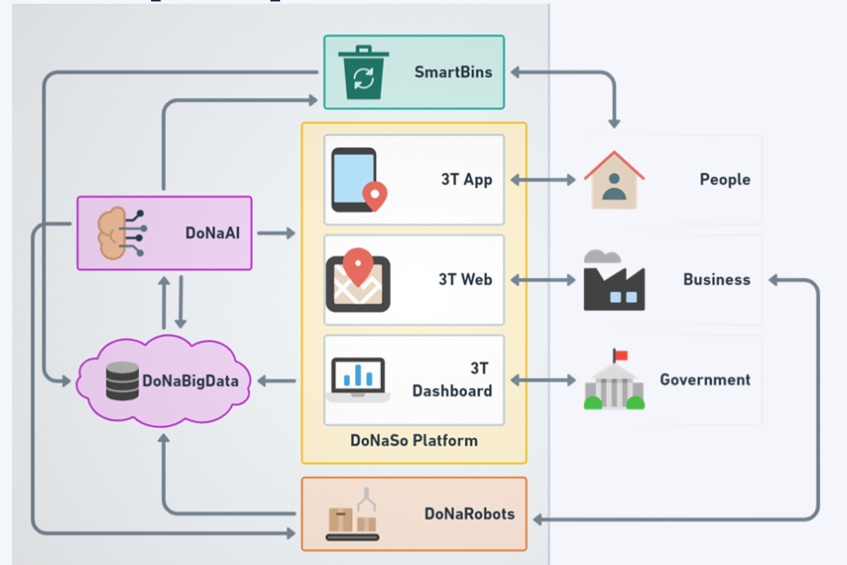
Figure 1 – DONASO System
As we have seen, the DONASO system consists of 5 main components [1]:
- DoNaAI: identifies and classifies waste, provides recommendations on waste treatment, notifications and reports.
- DonaBigData: Collect data, process data, design and deploy data warehouse.
- Donaso Platform: 3TApp mobile application, 3TWeb, 3TDashboard application
- Smartbin: is a smart trash bin, integrating DONaAI to identify and classify trash. The pilot will be used in schools and organizations to educate and guide proper trash classification.
- DonaRobots: is a DonaAI integrated robot that automatically classifies waste in the production line or is applied in mobile stations for automatic waste classification and processing.

The importance of the topic in practical application
The DoNaSo project was chosen with the goal of contributing to society and the environment. By building a big data processing and analysis system, we will be able to capture important information about waste, helping manage it more intelligently and effectively, which will help increase waste separation and recycling rates at source, meaning we will identify recyclable waste sources or provide information for the purpose of converting waste into reusable products, which helps reduce the amount of waste dumped into the environment and save natural resources to connect and provide businesses in the environmental sector. The market is a source of waste data with high economic value. This topic is also an opportunity to test the application of new and modern technologies in the field of big data processing. We will have access to technologies such as artificial intelligence, real-time data collection and analysis,...

Theoretical basis

Big data theory
Big data was born as a necessity of the 4.0 technology revolution and the explosion of the Internet market. Big data helps businesses learn, analyze and grasp customer insights, bringing about the right and strategic decisions in business. So what is big data? Big data are very large and complex data sets that are difficult to manage, store and analyze using traditional data processing tools. The important thing about big data is the ability to analyze and learn information from these data sets, because they often contain a lot of hidden information and important values. For example, the method of personalizing recommended content for each person on platforms such as Spotify, Netflix, Youtube, e-commerce platforms such as Shopee, Lazada,... [2]
Characteristics of big data associated with 5V:
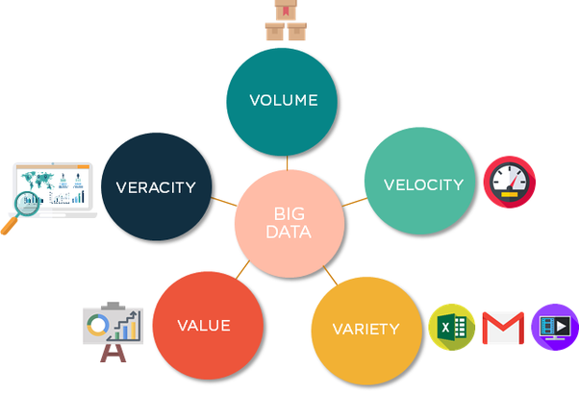
Figure 2 - Characteristics of big data
- Volume: This is the most typical characteristic of big data, the volume of data is very large. The size of Big data is increasing day by day, and as of 2012 it can range from a few dozen terabytes to many petabytes (1 petabyte = 1024 terabytes) for just one set of data. Traditional data can be stored on floppy disks and disks hard. But with big data we will use new "cloud" technology to meet the ability to store big data.
- Velocity: Speed can be understood in two aspects: (a) The volume of data increases very quickly (every second there are up to 72.9 million search access requests on Amazon's sales website); (b) Fast data processing in real-time, meaning data is processed immediately after it is generated (measured in milliseconds). Popular applications in the fields of Internet, Finance, Banking, Aviation, Military, Medical - Health today, most big data is processed in real-time. Today's big data processing technology has allowed us to process it instantly before it is stored in the database.
- Variety: As for traditional data, we often talk about structured data, but today more than 80% of the data generated is unstructured (documents, blogs, images, videos, songs, data from physical sensor devices, health care devices...). Big data allows linking and analyzing many different types of data. For example, with comments from a certain group of users on Facebook with video information shared from Youtube and Twitter.
- Veracity: One of the most complex properties of Big Data is the reliability/accuracy of the data. With today's social media and social networking trends and the sharp increase in interactivity and sharing by Mobile users, the picture is clear in terms of trustworthiness & Data accuracy is becoming more and more difficult. The problem of analyzing and eliminating inaccurate and noisy data is an important characteristic of Big data.
- Value: is the most important characteristic of big data, because when starting to build big data, the first thing we need to do is determine the value of the information, when Only then can we decide whether to deploy big data or not. If we have big data but only get 1% of the benefits from it, then we should not invest in developing big data. Accurate forecasting results clearly demonstrate the value of big data. For example, from the data generated during medical examination and treatment, health predictions will be more accurate, and treatment costs and other health-related costs will be reduced.
The conclusion shows that Big Data will create huge advantages for any business or organization. When we have a big enough data system and infrastructure, businesses or individuals can comprehensively analyze data, increase performance and optimize processes, predict and forecast, and understand clearly customers, data-based decisions,...
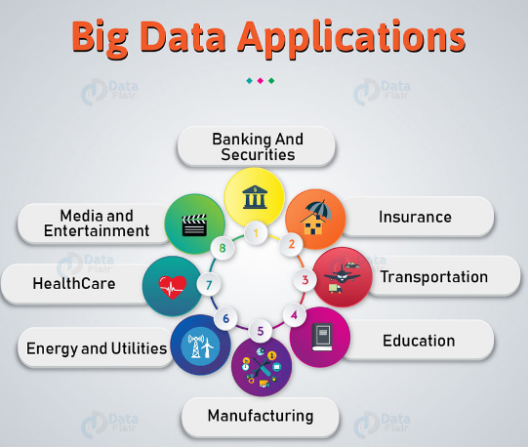
Figure 3 - Big data applications
Applying Big Data brings many important benefits to businesses, from prediction and optimization capabilities to in-depth customer understanding. However, deploying and using Big Data also faces many challenges. Managing large amounts of data, ensuring security and privacy, and integrating data from diverse sources present technical challenges. The cost of deploying and maintaining infrastructure can also be a major risk. In addition, lack of specialist skills, legal issues, and the ability to manage organizational cultural change are also important challenges.
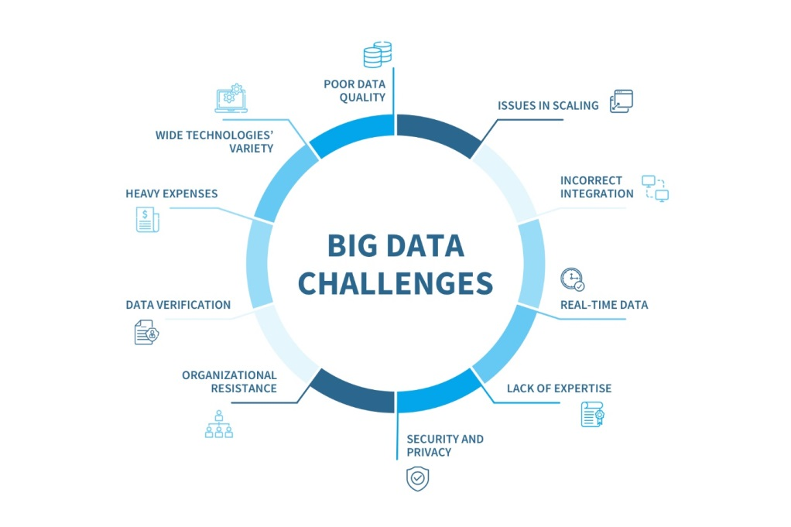
Figure 4 - Challenges of big data

The role of big data processing systems in smart technology solutions
The information technology revolution has promoted the continuous development of technology and changed the way we interact with data. With the growth of information technology, the ability to store and process big data, the development of programming languages and the power of artificial intelligence, we are moving into a future where we can solve complex challenges, including smart waste management.
Big data processing systems play an important role in converting unstructured and complex information into useful information, helping users manage and make smart decisions based on data. In addition, the big data processing system allows optimization of management processes through the use of real-time data and predictions. Big data processing systems are the heart of smart technology solutions because they connect different data sources and then link them together to process and analyze them. The data, after being cleaned, will be predicted and process automation, etc. Calling the call "Big data processing system is the heart of smart technology solutions" is to emphasize its important and indispensable role in making these solutions really smart and effective.

Applying big data systems in practice
Big data has become an important and necessary element in many practical fields. Applying big data systems brings many significant benefits, including making decisions based on data. When we have a fairly complete data system, this will help us. In terms of predicting future trends and optimizing decisions, applying big data will help us manage resources effectively. Businesses can use big data to better understand customer behavior, improve products and services, and create more effective marketing strategies. Big data systems can detect unusual behavior and find potential threats to safety and security, regardless of whether it is in a digital or physical environment. Big data systems have the ability to integrate and process data from many different sources, helping to create a more comprehensive and reliable view of a problem or situation, etc. There are also many other jobs. When applying the data system, it brings many unexpected results. This not only helps reduce the burden on people but also promotes development and modernization for the present and the future.

Research objectives
The main objective of the project will be to develop and deploy a big data processing and analysis system called DonaBigData to improve management and solve problems related to the management of quality information. Waste through smart technology solutions. The topic focuses mainly on data processing towards natural language processing. Below are the initial goals set for the project to guide a long-term direction for the project:
- Build a robust and secure big data infrastructure to store, manage and process data related to waste management in the DONASO project.
- Apply data analysis tools and software to extract useful information from big data, helping to manage waste more effectively.
- Ensure the safety and security of data, especially when handling sensitive information about the environment and the DONASO project.
- Assess the impact and performance of big data systems on waste management and build smart technology solutions.
- Propose strategies and recommendations for improving waste management and developing smart technology in the DONASO project based on reports visualized with data.

Topic research methods

Approach
To complete the project in the best way, the step of determining the approach is one of the most important initial methods, this method helps both identify the problems that need to be solved of the project as well as the direction of the project. project, the main approaches include: approaches to effectively collect, process and analyze data to ensure that IT solutions for data management regarding waste is implemented effectively and sustainably, below will be a summary of these methods to be able to go deeper into solving the problems:
+ Data collection: in the first phase of the DONASO project, I started with identifying and building the data sources needed to develop a smart waste management system. As a first step to test the effectiveness of the system, I used simulation data to simulate information related to the waste and collection process. This is necessary because I do not have actual data available at this time. To create simulation data, I identified and defined the basic types of waste that the system will have to process based on the waste taxonomy file provided by waste experts. I will use a fake data generation software to create data samples for each type of waste, including information about their volume, size, and physical properties, etc.
+ Load data into the data warehouse and build reports to analyze the data: this will include building a data warehouse according to common data models to optimize the ETL process of data from the input source target (also known as data pipelines process), instead of having to analyze data in the traditional way that only focuses on technology and tools, I will build a report to visualize the data so that users are not biased. technology can interact on the available reporting interface and find useful information from this data, helping users make better decisions based on data.

Tools and technologies used
In order for the project to be deployed and applied, we must use some popular technologies to do that. I will overview some of the technologies that I will use for this topic including: including tools for theoretical research, system design, project implementation, etc. The technologies will be briefly presented below:
+ Python: you should use Python for this project because Python is a general-purpose language that can be used in many parts of the project, from writing data processing code, analyzing data, to building interfaces, user interface and management systems. Python has the ability to integrate with many other technologies and systems. This is important in a waste project, where we need to link many different software and devices. Python has good performance for most big data processing applications and can be optimized using appropriate libraries and techniques.
+ SQL and NoSQL: I used both SQL and NoSQL in this project because SQL is often a good choice for structured data queries and critical data analysis when the data is in a data warehouse. NoSQL, in one respect, can be used to store unstructured data, even with high write and read frequencies. When we use both types of databases then we can optimize the performance of the project system.
+ PowerBI: I chose to use PowerBI to visualize data for this topic because Power BI allows us to create charts, graphs, and dashboards easily. This helps me display waste data visually, making it easier for users to understand the information and make data-driven decisions. Power BI provides strong security options to protect your data. We can control access and manage data securely and moreover PowerBI is a free version enough to use as an initial product.
+ Other tools like Apache Spark, Kafka, Airflow, Docker help me work with data better, specifically Apache Spark is a powerful big data processing framework for analyzing and processing data in large scale. It supports PySpark for Python language, which helps me perform complex tasks on garbage data efficiently. Apache Airflow helps me schedule, manage, and track tasks during data processing. This is important in organizing and automating project workflows. Apache Kafka is a powerful real-time data stream processing system. In a waste project, Kafka can be used as a funnel to dump data and data warehouses to avoid dumping too much data at once, which will affect the data warehouse. And finally for easy integration and deployment I use Docker which helps me package the application and necessary software into independent containers. This ensures integration and deployment of project components such as Spark, Airflow, Kafka and my application is easy and allows for reuse and system maintenance and development.
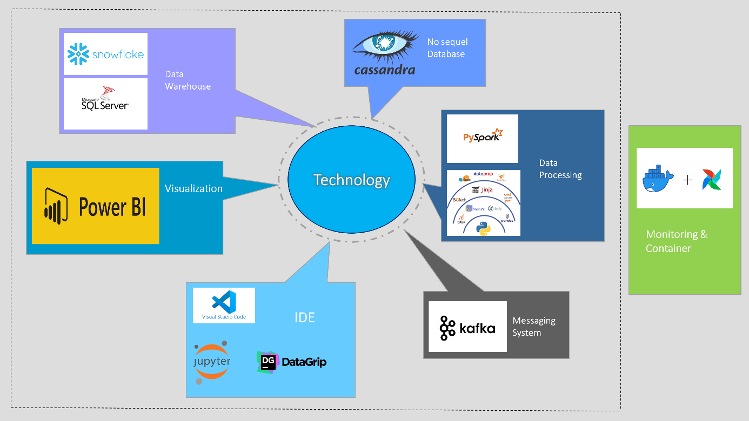
Figure 5 - Tools and Technology

Research limitations

Time and resource limitations
One of the important limitations of the DoNaSo project in general and DoNaBigData in particular is limited time. For a project to be complete and fully functional to launch, it takes a lot of time and resources. I myself have tried to overcome the limitations by not focusing on research and implementation. products that only follow an academic direction (including algorithms, processes, building system architecture,...). The next limitation is resources, because projects can only be carried out on personal computers, so sometimes the devices are not powerful enough to fully utilize the functions of reading and writing large data, as well as limited machine configuration. Limited resources are also a difficult problem for individuals. Despite facing these limitations, I still tried to make the most of available resources and time to achieve important project goals, and these limitations helped me better understand Challenges and opportunities in developing smart waste management systems

Data limitations
One of the main limitations of the DoNaSo project is the lack of real data on waste management. This issue has posed a major challenge in building and evaluating the system later. Real data is often complex and detailed. Due to time and resource limitations, I was unable to collect and process every aspect of the data in as much detail as I would have liked. This can lead to limitations in capturing complex situations in waste management. To overcome this problem as described in the data collection section, the project will use fake data as presented in the previous section to create data simulations. However, fake data has limited realism and does not completely reflect the reality of waste and collection processes. This can reduce the accuracy of research results if followed in the long term. But to overcome this, in the future we will build web/app platforms for users and machines to integrate data here. Then the actual data will be saved to log files. From here we will get real data to better take the next steps of your project.

SYSTEM ANALYSIS AND DESIGN

Waste-Centric and User-Centric Analysis

Dual Focus: Objectives and Stakeholders
Our analysis begins with a dual focus: optimizing waste processing efficiency and addressing the diverse needs of stakeholders. We explore various waste types, such as organic, recyclable, and hazardous materials. Simultaneously, we identify a broad spectrum of stakeholders, including environmental agencies, administrators, local residents, and businesses connected to or influenced by waste processing.

In-Depth Understanding: Requirements and Analysis
Through a comprehensive approach involving meetings, surveys, and interviews, we gather nuanced insights into current waste processing methods, challenges, and the specific expectations of our diverse user base.
Transitioning to the analysis phase, we meticulously dissect the collected data to unveil specific waste and user requirements. This process lays the foundation for subsequent stages in system development, ensuring a solution aligned with technical benchmarks and practical stakeholder needs.

Holistic Perspective: System Interaction and User Experience
To enhance clarity without relying on technical visual aids, we adopt a narrative approach to describe how the system interacts with various waste types and caters to diverse user needs. Our emphasis is on providing a holistic understanding through clear storytelling.
In evaluating the system, we prioritize qualitative assessments over formalized metrics. Practical observations and user feedback become key indicators of system effectiveness. This approach allows for a nuanced understanding of the system's capabilities without being confined to rigid quantitative measures.

System Architecture

Architectural Vision
The DONASO system is built with a distributed architecture, including main components such as Big Data Processing Layer, Data Warehouse and data usage applications. Big Data Processing Layer includes Cassandra (NoSQL), SQL Server and MySQL (SQL) to meet both structured and unstructured data storage needs. Data is transmitted between these components via Kafka, which enables real-time data processing. I use NoSQL(Cassandra) as a data lake to store files like XML, Json, Csv, from garbage audit sources and real-time AI recognition system, and MySQL as a database that works on on 3T App systems. The system integrates tightly with Data Warehouse through the ETL (Extract, Transform, Load) process. Airflow is used to manage the ETL schedule, ensuring that data is transformed and updated in sync with the Data Warehouse.
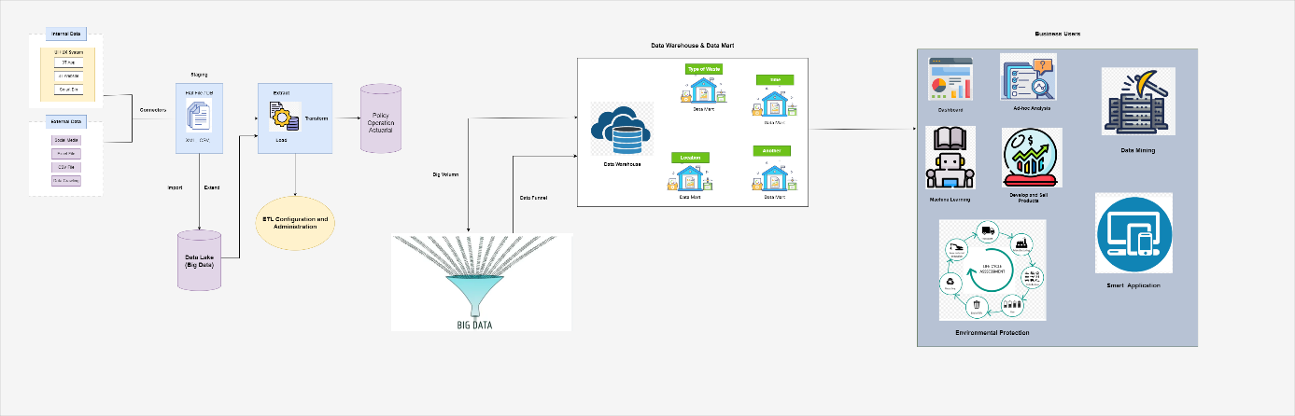
Figure 6 - System overview

Components and Modules
As for the architectural overview of this project's system that I mentioned above, I will continue to demonstrate how I will work with each system component by applying the following technologies:
- Cassandra (NoSQL): Used to store unstructured data such as logs and sensor information from the DONASO project.
- SQL Server and MySQL (SQL): Used to store structured data such as waste processing information and system information. More specifically, I will use SQL Server mainly as a data warehouse
- Python, PySpark: Used for analyzing and processing big data, especially when needing to perform complex tasks such as predictive analytics.
- Kafka: Used to process data in real time and convert data between system components.
- Docker: Used to package applications and execution environments, increasing flexibility in deployment and system management.
- Airflow: Integrated to automate the ETL process and schedule automated jobs in the system.
- PowerBI: Use to create dashboards and reports, helping users monitor and evaluate system performance.
My systems all have dependencies on each other to create an easy to manage federation such as: Cassandra stores unstructured data and feeds it to PySpark to perform big data analytics, SQL Server and MySQL stores structured data and is a data source for PowerBI to create dashboards and reports, Kafka ensures information transfer between system components, helping to maintain real-time in data processing.

Scalability and Flexibility
Regarding design considerations for future expansion, I chose Cassandra as the data lake, to store unstructured data and support a flexible expansion model, helping the system expand easily according to needs. data enhancement. The purpose of doing this is if in the future, if data continues to be generated and personnel work with limited data to perform operations with the data, the data lake will perform another ELT process again. with ETL in that it will automatically extract and save it to itself, when I want to use it I just need to trasnform and retrieve it again for analysis.
Furthermore to adapt to future requirements, we will use Docker to package the application and create a standalone execution environment, making the system easy to adapt to future requirements and deploy smoothly. flexible way. Using docker not only helps us operate our applications and systems well on other platforms and servers if we have expansion purposes.

Data Warehouse Design

Data warehouse theory
A Data Warehouse (DW) is a relational database that is designed for query and analysis rather than transaction processing. It includes historical data derived from transaction data from single and multiple sources. A Data Warehouse provides integrated, enterprise-wide, historical data and focuses on providing support for decision-makers for data modeling and analysis.
A Data Warehouse can be viewed as a data system with the following attributes: It is a database designed for investigative tasks, using data from various applications. It supports a relatively small number of clients with relatively long interactions. It includes current and historical data to provide a historical perspective of information. Its usage is read-intensive. It contains a few large tables.
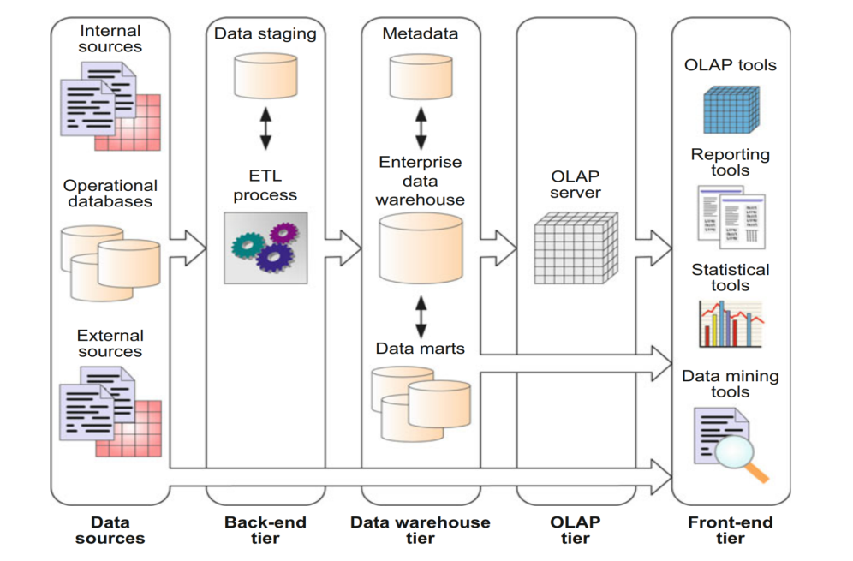
Figure 7 - Data warehouse overview architecture
Characteristics of Data Warehouse is a subject-oriented, integrated, and time-variant store, Furthermore, it is non-volatile.

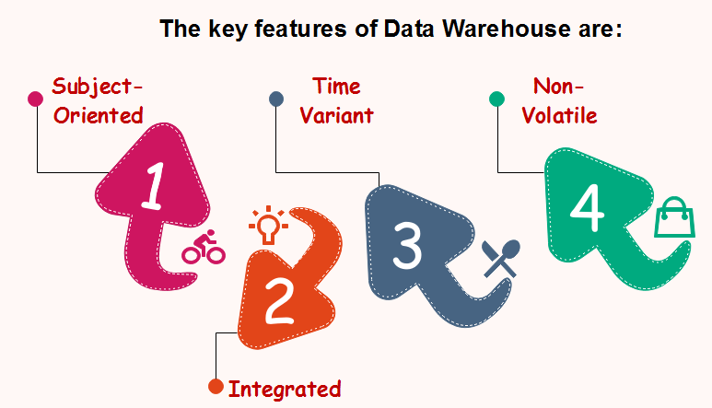
Figure 8 - Main characteristics of data warehouse
A data warehouse target on the modeling and analysis of data for decision-makers. Therefore, data warehouses typically provide a concise and straightforward view around a particular subject, such as customer, product, or sales, instead of the global organization's ongoing operations. This is done by excluding data that are not useful concerning the subject and including all data needed by the users to understand the subject.
A data warehouse integrates various heterogeneous data sources like RDBMS, flat files, and online transaction records. It requires performing data cleaning and integration during data warehousing to ensure consistency in naming conventions, attributes types, etc., among different data sources.
Historical information is kept in a data warehouse. For example, one can retrieve files from 3 months, 6 months, 12 months, or even previous data from a data warehouse. These variations with a transactions system, where often only the most current file is kept.
The data warehouse is a physically separate data storage, which is transformed from the source operational RDBMS. The operational updates of data do not occur in the data warehouse, i.e., update, insert, and delete operations are not performed. It usually requires only two procedures in data accessing: Initial loading of data and access to data. Therefore, the DW does not require transaction processing, recovery, and concurrency capabilities, which allows for substantial speedup of data retrieval. Non-Volatile defines that once entered into the warehouse, and data should not change.
To better understand data warehouses and the differences between data warehouses and relational databases, the table below provides an overview.
Table 1 - Compare data warehouse and database
Characteristic | Data warehouse | Database
Main purpose | Store and analyze big data to support strategic business decisions | Store and manage data to support daily transactions
Nature and amount of data | Large amounts of data are mainly historical data and are integrated and processed from many different sources, data is maintained and uploaded regularly. | Small or medium amount of data, mainly coming from a number of fixed sources, data updated in real time or periodically, transaction transactions
Tools used | Data analysis tools such as OLAP, BI | Popular database management systems such as Oracle, SQL Server, MySQL,...
Cost and implementation | High costs due to powerful hardware requirements, complex implementation, and requirement of an experienced team of operations experts | Lower costs than data warehouses, more flexible and simpler design implementation
Query performance | Good performance for complex queries and reports | Good performance for basic queries and data logging
Privacy Policy | Powerful, customizable rights management and security systems are linked | Security and permission management are designed to meet your application's specific requirements

When using and designing a good enough data warehouse for the project "Building a Big Data Processing and Analysis System for Smart Technology Solutions in Waste Treatment Project" we will see get the following benefits:
- Optimize Waste Processing Processes: A large data warehouse can store and manage large amounts of data from different sources such as sensors, monitoring systems, and IoT devices. This helps you better understand the waste treatment process, thereby optimizing and improving performance.
- Predict Future Trends and Demand: The data warehouse will be a source of information to predict trends in the waste situation. This way, you can respond to future needs and design solutions with flexibility.
- Strategic Decision Support: Data is the key to making strategic decisions. A high-quality data warehouse will help you see more clearly about the market, supply, and demand, thereby shaping your project's development strategy.
- Enhanced Performance and Energy Savings: By analyzing data, you can identify areas where performance can be improved and unnecessary waste reduced, leading to energy and resource savings.
- Propose strategies and recommendations for improving waste management and developing smart technology in the DONASO project based on reports visualized with data.
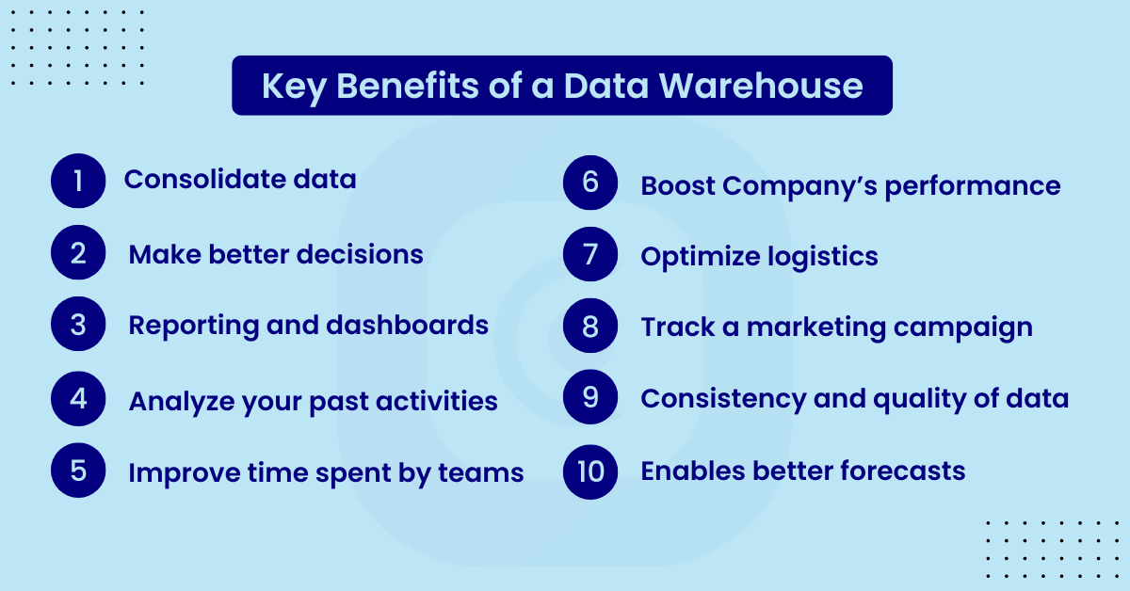

Figure 9 - Benefits of Data warehouse

Data warehouse deployment scenario
In this section, I will delve into the important process of how to design and implement a data warehouse within the framework of the DONASO project? It's not just about choosing between On-Premise and Cloud, it's also about building a robust infrastructure to ensure data warehouse performance, scalability, and security.
To understand and choose which data warehouse to deploy on which infrastructure, we also need to understand what is deployed on-premises and what is deployed in the cloud:
- In on-premises, from use to the running of the course of action, everything is done inside; whereby backup, privacy, and updates moreover should be managed in-house. At the point when the item is gotten, it is then installed on your servers; requiring additional power laborers, database programming software and operating systems to be purchased. With no prior commitment, you anticipate complete ownership.
- Cloud refers to the delivery of on-demand computing services over the internet on “Pay As U Use “services, in simple words rather than managing files and Services on the local storage device you can do the same over the Internet in a cost-efficient manner. With a Cloud-based enrolment model, there is no convincing motivation to purchase any additional establishment or licenses.
We can see difference between On-Premises and On Cloud through tables below:
Table 2 - Compare On-premise and On-cloud
Characteristic | On-Premises | On Cloud
Control of User | More control as the enterprise manages it. | Less control, involvement of third parties.
Infrastructure Scalability | Most Infrastructure is local environment so not easy to scale | Deploymented on the internet so easy to scale
Service Access | Limited to the enterprise. | Accessed beyond the enterprise.
Flexibility and Update Responsibility | Enterprise is responsible for updates so not quite flexible. | Second party is responsible for updates so high quite flexible.
Cost and Time | Fixed cost and more time-consuming. | Flexible costs paid according to resources used and less more time-consuming
Security | More secure | Less secure, information stored in the cloud.

Currently, I am planning to initially deploy the DONASO project's data system on an on-premise environment with the following reasons: I want to have complete control over my data, because I only do it on a personal computer so I feel the initial cost is low because I already have the initial physical configuration, moreover this is a project aimed at improving ability to test and develop projects in practice. First, we will continue to deploy and maintain the system on-premise to ensure stability and performance. However, in the future, as the project expands and resource needs increase, we plan to move some of the data to the cloud, with Snowflake as the primary data management platform. This will help us take advantage of the flexibility and scalability of the cloud environment, while reducing the burden of infrastructure management. Snowflake, with its good integration capabilities across multiple cloud platforms, will be the ideal choice for ensuring consistency and synchronization between on-premise and cloud data [3].
When it comes to data warehouse modeling, we should know how the components will be in the data warehouse? The data warehouse model has two main types of entities: measures and dimensions. It is fundamental to understand the differences between facts and dimensions in a data warehouse for creating a flawless database design. Facts are the measurable events related to the functional area covered by a data warehouse. For example, sales are facts in a data warehouse for the sales and distribution area of a company. If the data warehouse contains information about patient care in a hospital, patient visits to the hospital are facts. Fact tables are the core tables of a data warehouse. They contain quantitative information, commonly associated with points in time. They are used in trends, comparisons, aggregations, and groupings. They feed analysis and visualization tools to allow insights to be discovered about the functional area. Dimensions, on the other hand, are collections of reference information about the facts in a data warehouse. Dimensions categorize and describe the facts recorded in a data warehouse to provide meaningful, categorized, and descriptive answers to business questions. In the design of a data warehouse, it is common to create dimension tables first and then create fact tables by relating them to the dimension tables through foreign keys.
Now that we understand the components of a data warehouse, I'll talk about the common types of data warehouses that should be designed, this includes things like how to design them, their benefits and disadvantages when implemented currently deployed, There are two main design options for data warehouses: star schema and snowflake design:
- Star schema is the type of multidimensional model which is used for data warehouse. In star schema, The fact tables and the dimension tables are contained. In this schema fewer foreign-key join is used. This schema forms a star with fact table and dimension tables.
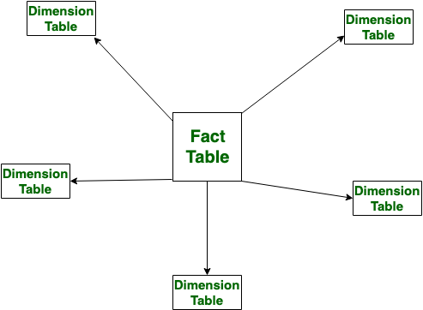
Figure 10 - Model of star example
- Snowflake Schema is also the type of multidimensional model which is used for data warehouse. In snowflake schema, The fact tables, dimension tables as well as sub dimension tables are contained. This schema forms a snowflake with fact tables, dimension tables as well as sub-dimension tables.
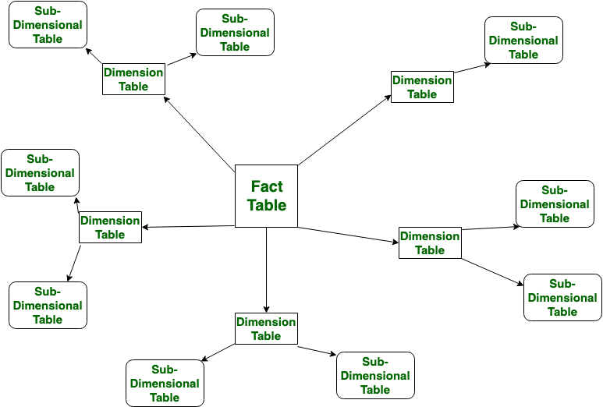
Figure 11 - Model snowflake example
Let’s see the difference between Star and Snowflake Schema:
Table 3 - Compare of Star Schema and Snowflake
Feature | Star Schema | Snowflake
Structure | Fact and dimension tables are contained in a single structure. | Fact tables, dimensions, sub-dimensions are organized.
Modeling Approach | Top-down model. | Bottom-up model.
Query Performance | Lower query complexity and generally faster query execution. | Higher query complexity, especially with multiple joins and may take more time for query execution due to joins
Design Complexity | Simple design and has fewer foreign keys | More complex design, especially with nested structures and more foreign keys, especially in sub-dimension tables.

When faced with the task of creating a data model for a warehouse, you may be tempted to use your favorite SQL client and start creating tables right away. This may work for a very small data warehouse. But data warehouses are not exactly known for being small. For this reason, using the “quick & dirty” methodology to create a data warehouse is decidedly a bad idea. This is mainly because, once the data warehouse is full of data, modifying its structure is quite a difficult task. We must keep in mind that a data warehouse – even more than a database – is a strategic and critical tool for business. For this reason, we must minimize all possible risks during its construction.
To design a good data warehouse, the first step is to establish processes and principles to research, design and deploy the data warehouse. One of them is standard data warehouse design based on data warehouse modeling lifecycle. Data warehouse modeling is the process of designing the schemas of the detailed and summarized information of the data warehouse. The goal of data warehouse modeling is to develop a schema describing the reality, or at least a part of the fact, which the data warehouse is needed to support. The objective of the data modeling life cycle is primarily the creation of a storage area for business information. That area comes from the logical and physical data modeling stages, as shown in Figure:
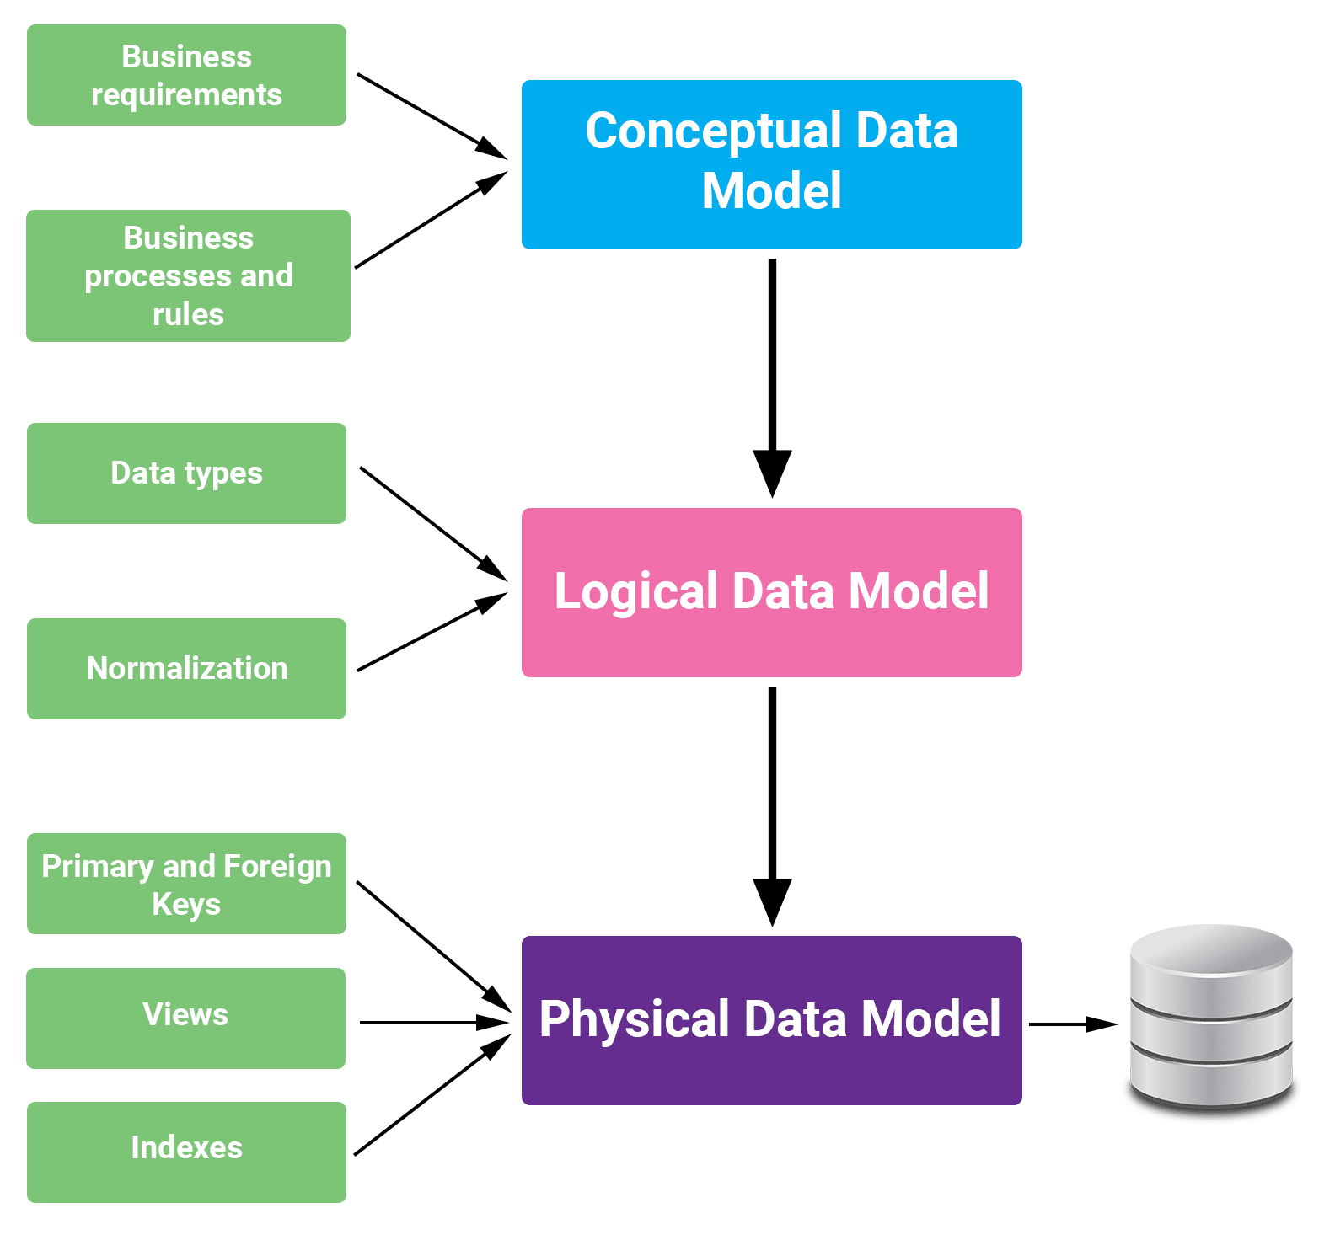
Figure 12 - Design data warehouse step by step
As we can see understand Business Objectives and Processes is important step because the first phase of creating a data model for a data warehouse involves requirements engineering work, in which you gain an overall understanding of the information and results you expect from using the data warehouse. As a result of this first phase, you should get a detailed description of data warehouse requirements; this serves as input for the next phase.
Data modeling in data warehouses is different from data modeling in operational database systems. Thus, the objective of data warehouse modeling is to make the data warehouse efficiently support complex queries on long term information.

Conceptual data warehouse design
A conceptual data model recognizes the highest-level relationships between the different entities. Characteristics of the conceptual data model are:
- It contains the essential entities and the relationships among them.
- No attribute is specified.
- No primary key is specified.
We can see that the only data shown via the conceptual data model is the entities that define the data and the relationships between those entities. No other data, as shown through the conceptual data model.
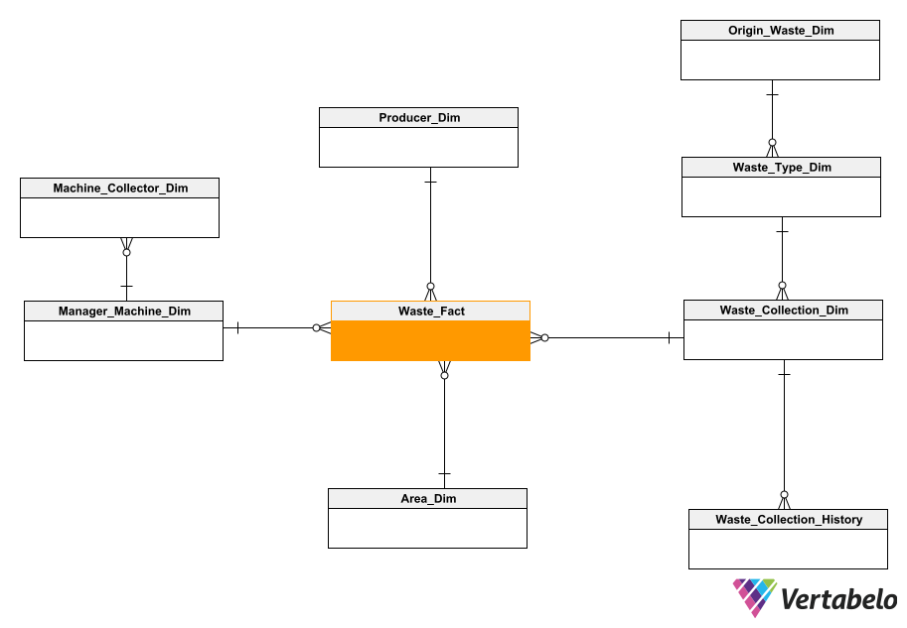
Figure 13 - Design conceptual data warehouse model
We can see the fact tables are central to the diagram. They contain two fundamental types of attributes: numerical measures and dimension identifiers. Numerical measures are aggregate values (totals, averages, etc.) for each combination of dimension identifiers. For the construction of the conceptual model, we do not need to define the diagram down to the smallest detail. It is enough to show the fact tables, the dimension tables, and the relationships between them. This diagram will help us explain the model to users and stakeholders. The goal is to obtain feedback and approval so that when the database is running there is no possibility of misunderstandings and complaints [1].
According to the conceptual data warehouse image that I designed above, we can see that dimensions such as Machine_Collector, Origin_Waste, Waste_Type are not directly connected to the Waste_Fact table but must be connected through dimension tables, other like Manager_Machine, Waste_Collection. The hierarchies used are balanced hierarchies, the tables are connected to each other through a 1-n relationship.

Logical data warehouse design
A logical data model defines the information in as much structure as possible, without observing how they will be physically achieved in the database. The primary objective of logical data modeling is to document the business data structures, processes, rules, and relationships by a single view - the logical data model.
As the logical data model defines the structure of the data elements based on fundamental business requirements as well as the relationships between them, not having a logical data model in place means a lot of missed opportunities for improving business processes. Developers simply end up automating existing procedures, or recreating legacy systems on a newer technological platform which may eventually become obsolete and when we will design logical data model we have advantages of a logical data model:
- As objects in the logical data model bear textual definitions in business language, it makes it easier to maintain and access system documentation.
- Logical data models can be used for impact analysis, as each and every business process plus rule is connected within it.
- Components of the building process, namely, design, coding, testing, and deployment go faster, as a direct result of the integration and clarification of business rules.
- As data remains stable over time, a logical data model is also a stable one and highly conducive to data re-use and physical data sharing, which ultimately leads to reduced storage of redundant data.
Features of a logical data model:
- It involves all entities and relationships among them.
- All attributes for each entity are specified.
- Referential Integrity is specified (FK Relation).
- The primary key for each entity is stated.
After research and comparison, I have designed a model at the Logical level built with the starflake schema, a combination of the star schema and the snowflake schema to minimize the limitations of both schemas.
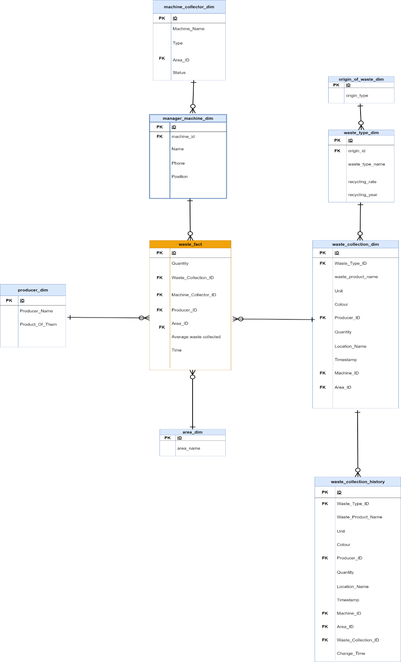
Figure 14 - Logical data warehouse design

Physical data warehouse design
Physical data model describes how the model will be presented in the database. A physical database model demonstrates all table structures, column names, data types, constraints, primary key, foreign key, and relationships between tables. The purpose of physical data modeling is the mapping of the logical data model to the physical structures of the RDBMS system hosting the data warehouse. This contains defining physical RDBMS structures, such as tables and data types to use when storing the information. It may also include the definition of new data structures for enhancing query performance. Summarize in a physical data model, we care about how the system can store the actual data.
Characteristics of a physical data model:
- Specification all tables and columns.
- Foreign keys are used to recognize relationships between tables.
- Convert entities to tables.
- Convert relationships to foreign keys.
- Convert attributes to columns.
From the data warehouse at the conceptual and logical level, next to be able to store data in tabular form for visualization, we will build a data warehouse at the physical level with the properties of objects. details and relationships between objects as well as defining specific data types for each attribute of the object. To build a data warehouse that is good enough and applicable for long-term purposes, it is important to define data types for objects at the initial time of building the data warehouse. From determining the requirements of the topic [4], I have built data tables for each specific subject as follows:
Table 4 - Origin of waste dimension
N.o | Column Name | Data Type | Description | Note
1 | id | Tinyint | Indentity(1,1) | Primary Key
2 | origin_type | Varchar(255)

Table 5 - Waste type dimension
N.o | Column Name | Data Type | Description | Note
1 | ID | Smallint | Indentity(1,1) | Primary Key
2 | origin_id | Tinyint |  | Foreign Key (origin_of_waste_dim)
3 | waste_type_name | Varchar(255) | Classify waste such as plastic products, organic products, etc. | Abbreviation restrictions and not null
4 | recycling_rate | float | Recycling rate of that type of waste
Table 6 - Producer dimension
N.o | Column Name | Data Type | Description | Note
1 | Smallint | Tinyint | Indentity(1,1) | Primary Key
2 | producer_name | Varchar(255)
3 | product_of_them | Varchar(255)
Table 7 - Area dimension
N.o | Column Name | Data Type | Description | Note
1 | id | Tinyint | Indentity(1,1) | Primary Key
2 | Area_name | Varchar(255) | The current area is the districts in Da Nang

Table 8 - Machine collector dimension
N.o | Column Name | Data Type | Description | Note
1 | Id | Int | Indentity(1,1) | Primary Key
2 | Type | Varchar(255)
3 | Status | Varchar(50) | Active, off, pending
4 | Area_id | Tinyint |  | Foreign Key (area_dim)
Table 9 - Manager machine dimension
N.o | Column Name | Data Type | Description | Note
1 | Id | Smallint | Indentity(1,1) | Primary Key
2 | Machine_id | int |  | Foreign Key (machine_collector_dim)
3 | Name | Varchar(255)
4 | Phone | Varchar(10) | According to Vietnam's phone number structure
5 | Position | Varchar(255)
Table 10 - Waste collection dimension
N.o | Column Name | Data Type | Description | Note
1 | Id | Int | Indentity(1,1) | Primary Key
2 | waste_type_id | Smallint |  | Foreign Key(waste_type_dim)
3 | waste_product_name | Varchar(255)
4 | Unit | Varchar(100) | Calculated in units such as kg, g, l, ml, etc
5 | Colour | Varchar(255)
6 | Producer_id | Smallint |  | Foreign Key(producer_dim)
7 | Quantity | Float
8 | Location_name | Varchar(255) | Where is this garbage collected (school, hospital, etc)
9 | Timestamp | Datetime | Time when waste is collected
10 | Machine_id | Int |  | Foreign Key(machine_collector_dim)
11 | Area_id | Tinyint |  | Foreign Key(area_dim)
Table 11 - Waste collection history
N.o | Column Name | Data Type | Description | Note
1 | Id | Int | Indentity(1,1) | Primary Key
2 | waste_type_id | Smallint |  | Foreign Key(waste_type_dim)
3 | waste_product_name | Varchar(255)
4 | Unit | Varchar(100) | Calculated in units such as kg, g, l, ml, etc
5 | Colour | Varchar(255)
6 | Producer_id | Smallint |  | Foreign Key(producer_dim)
7 | Quantity | Float
8 | Location_name | Varchar(255) | Where is this garbage collected (school, hospital, etc)
9 | Timestamp | Datetime | Time when waste is collected
10 | Machine_id | Int |  | Foreign Key(machine_collector_dim)
11 | Area_id | Tinyint |  | Foreign Key(area_dim)
12 | Waste_collection_id | Int |  | Foreign Key(waste_collection_dim)
13 | Change_time | Datetime | Save the time the changes were made

Table 12 - Waste fact
N.o | Column Name | Data Type | Description | Note
1 | Id | Int | Indentity(1,1) | Primary Key
2 | Quantity | Float
3 | Average_waste_collected | Float
4 | Timestamp | Datetime
5 | Waste_collection_id | Int |  | Foreign Key(waste_collection_dim)
6 | Machine_id | Int |  | Foreign Key(machine_collector_dim)
7 | Producer_id | Smallint |  | Foreign Key(producer_dim)
8 | Area_id | Tinyint |  | Foreign Key(area_dim)

ETL (Extract, Transform, Load) Processes
The mechanism of extracting information from source systems and bringing it into the data warehouse is commonly called ETL, which stands for Extraction, Transformation and Loading. The ETL process requires active inputs from various stakeholders, including developers, analysts, testers, top executives and is technically challenging. To maintain its value as a tool for decision-makers, Data warehouse technique needs to change with business changes. ETL is a recurring method (daily, weekly, monthly) of a Data warehouse system and needs to be agile, automated, and well documented [6] [7].
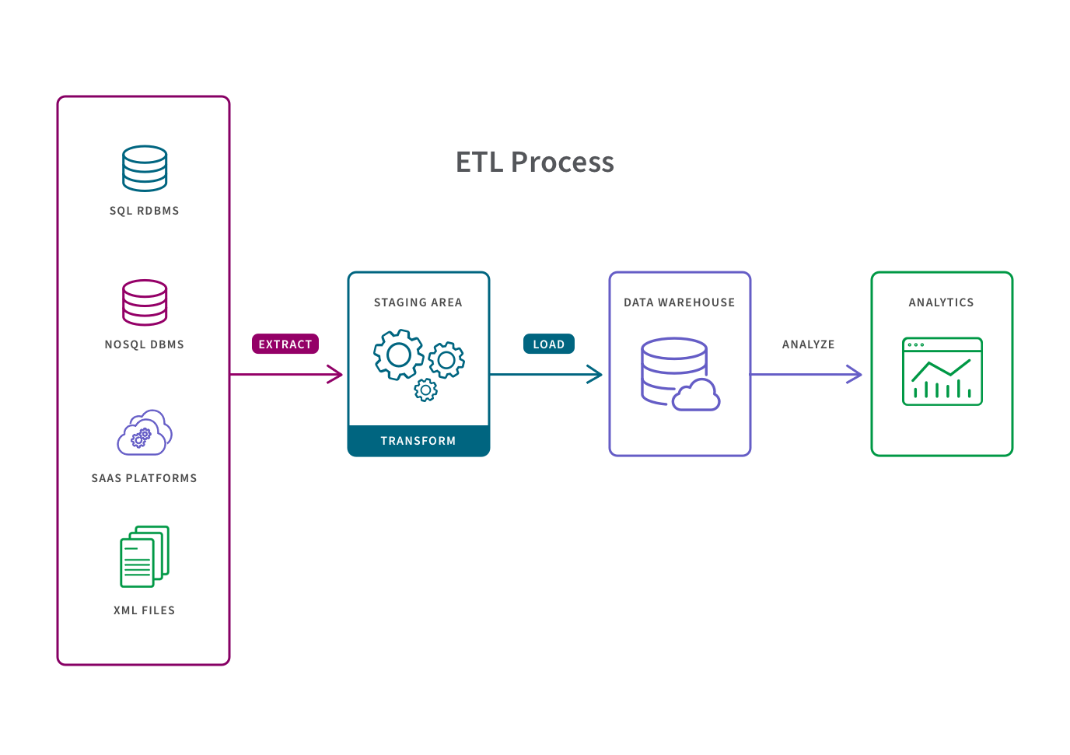
Figure 15 - Extract - Transform - Load Process

Data extract process
Extraction is the operation of extracting information from a source system for further use in a data warehouse environment. This is the first stage of the ETL process. Extraction process is often one of the most time-consuming tasks in the ETL. The source systems might be complicated and poorly documented, and thus determining which data needs to be extracted can be difficult. The data has to be extracted several times in a periodic manner to supply all changed data to the warehouse and keep it up-to-date.
Whether the source is a database, a SaaS platform, Excel spreadsheet, web scraping, or something else, the process to extract information involves the following steps:
- Check for changes to the structure of the data, including the addition of new tables and columns. Changed data structures have to be dealt with programmatically.
- Retrieve the target tables and fields from the records specified by the integration’s replication scheme.
- Extract the appropriate data, if any.
Extraction jobs may be scheduled, or analysts may extract data on demand as dictated by business needs and analysis goals. There are three primary types of data extraction, listed here from most basic to most complex: update notification, incremental extraction, full extraction.

Data transformation process
Transformation is the core of the reconciliation phase. It converts records from its operational source format into a particular data warehouse format. If we implement a three-layer architecture, this phase outputs our reconciled data layer. Also, during the transformation process, I always combine it with the data cleaning process because I know the cleansing stage is crucial in a data warehouse technique, it is supposed to improve data quality. The primary data cleansing features found in ETL tools are rectification and homogenization. They use specific dictionaries to rectify typing mistakes and to recognize synonyms, as well as rule-based cleansing to enforce domain-specific rules and defines appropriate associations between values. The following points must be rectified in this phase:
- Loose texts may hide valuable information. For example, XYZ PVT Ltd does not explicitly show that this is a Limited Partnership company.
- Different formats can be used for individual data. For example, data can be saved as a string or as three integers.
- Conversion and normalization that operate on both storage formats and units of measure to make data uniform.
- Matching that associates equivalent fields in different sources.
- Selection that reduces the number of source fields and records.
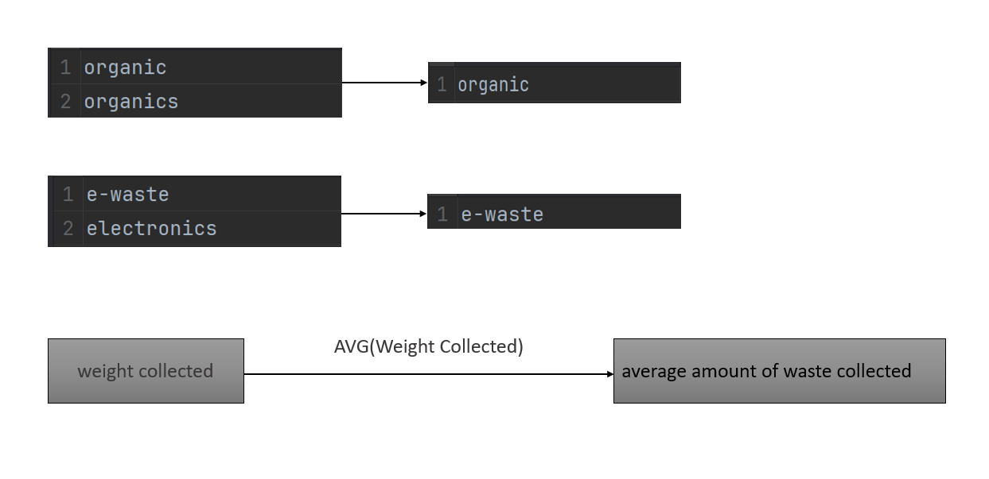
Figure 16 - Transform output in the project
As in my project, performing the transformation process is how I choose the most suitable name among many categories (because it is essentially the same but when entering the name is different), I applied the transformation process To generate the desired output for the target data, next we can see that to calculate the average value of the total amount of waste collected by weight, I transformed the data of the resulting weight column with the function to calculate the average value to get the desired results,...Based on the conceptual and logical data warehouse I designed above, we can now deploy a physical data warehouse based on the object information tables that I also outlined above. and we will deploy this physical data warehouse using the SQL Server database management system.

Data loading process
Loading is the ultimate step in the ETL process. In this step, the extracted data and the transformed data are loaded into the target database. To make the data load efficient, it is necessary to index the database and disable the constraints before loading the data. All three steps in the ETL process can be run parallel. Data extraction takes time and therefore the second phase of the transformation process is executed simultaneously. This prepared the data for the third stage of loading. As soon as some data is ready, it is loaded without waiting for the previous steps to be completed.
The entire process of transferring data to a data warehouse repository is referred to in the following ways:
Initial Load: For the very first time loading all the data warehouse tables.
Incremental Load: Periodically applying ongoing changes as per the requirement. After the data is loaded into the data warehouse database, verify the referential integrity between the dimensions and the fact tables to ensure that all records belong to the appropriate records in the other tables. We must verify that each record in the fact table is related to one record in each dimension table that will be used in combination with that fact table.
Full Refresh: Deleting the contents of a table and reloading it with fresh data.
Methods for data loading:
- Batch processing: With batch approach we process the data at given time (every 4 hours, every Monday morning, each night, etc.). Such solution has the biggest latency which is given by refresh period — hours or days. With batch processing we can process all the data at given time (full load) or do just deltas.
- Real time processing: Last approach has the best latency. If we need latency in seconds we need to process the data in near real time or real time. This approach is frequently associated with processing data from various IoT sensors, Apps & APIs or logs. Furthermore, processing here is event-based, which categorizes it as event-driven. But it is not based on files anymore. Usually there is some event broker in the middle which collect the data from sources and broadcast them to all the listeners (data consumers). The communication between sources and consumers is asynchronous which means sources are pushing new data without any synchronization with consumers and consumers consume data based on their own needs without any communication/sync with sources. Typical broker tool is Apache Kafka which works as message broker, but there are others, even managed services from the cloud providers like AWS Kinesis.
Because the data transmitted from the 3T app system is expected to be determined as continuous data, but at the same time, the audit file data is only calculated monthly or quarterly, so the real-time design for the system is difficult. My download was not feasible and would have been costly, so I designed the algorithm to load data in batch and have a near real-time portion for data from websites and applications.
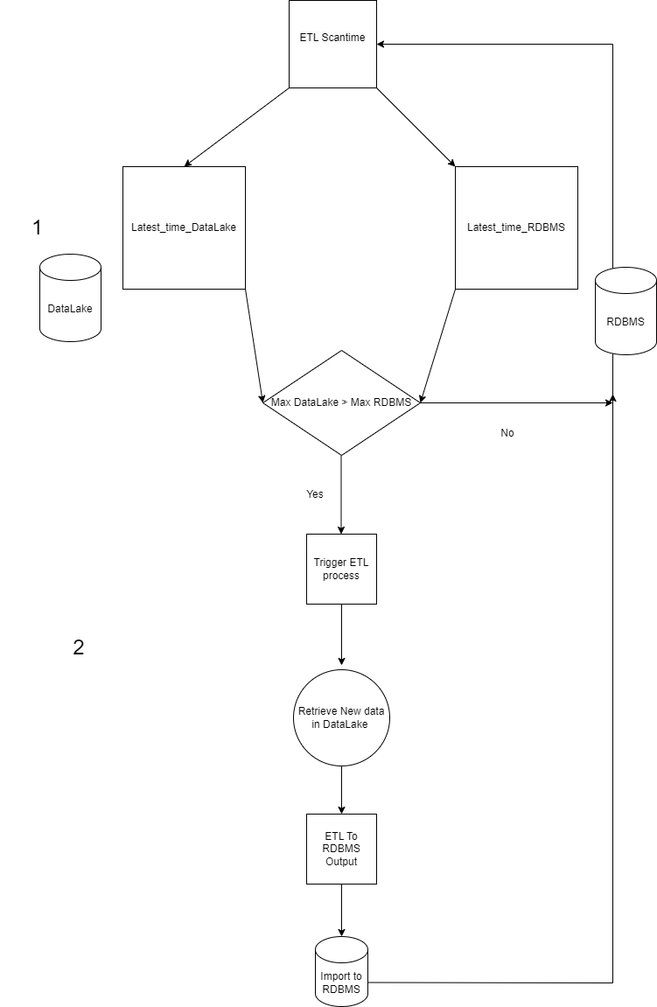
Figure 17 - Near real-time and real-time algorithms for loading process
According to the algorithm that I designed, in short, the data will be checked by me (according to the schedule that I have previously installed) in the datalake if the current data in my data warehouse has time to update. The smaller the new data is integrated into the data lake, we will perform the data ETL process.

Integration and Interoperability
In the pursuit of developing a robust Big Data processing and analysis system for the DONASO Waste Treatment Project, the integration and interoperability aspects play a pivotal role in ensuring seamless communication and collaboration between different component

System Itegration
The system integration component of our project involves the collaboration of three essential database servers. To facilitate a smooth integration process, we adhere to established protocols and standards, ensuring compatibility and communication harmony between these servers and other system components.
- Protocols and Standards: Our system adheres to industry-standard protocols such as RESTful APIs (Representational State Transfer), which provide a lightweight and flexible approach to integrate diverse components within the system. Additionally, we leverage open standards like JSON (JavaScript Object Notation) for data interchange, enhancing interoperability and simplifying communication between the databases and other system elements.
- Interoperability: is a key consideration in the design and implementation of our system. We ensure that the three database servers seamlessly interact with each other and other relevant components. This includes compatibility with existing waste treatment systems or any other applicable external systems.

Integration and Interoperability with Power BI
Integration with Power BI is a critical aspect of our data processing and analysis system, providing a powerful platform for reporting and dashboarding. This integration enhances the accessibility and visualization of insights derived from the data warehouse and other system components. To achieve a cohesive integration with Power BI, we employ multiple mechanisms: special as Data Warehouse Integration: the Data Warehouse acts as a central repository for structured and unstructured data. We utilize Power BI connectors specifically designed for data warehousing solutions, ensuring a direct and efficient link between the warehouse and Power BI. A Power BI user takes data from various data sources such as files, Azure source, online services, DirectQuery or gateway sources. Then, they work with that data on a client development tool such as Power BI Desktop. Here, the imported data is cleaned and transformed according to the user’s needs. Once the data is transformed and formatted, it is ready to make visualizations in a report. A report is a collection of visualizations like graphs, charts, tables, filters, and slicers. Moving on to the chain of processes, you can publish the reports created in Power BI desktop on two platforms; Power BI Service and Power BI Report Server [4].
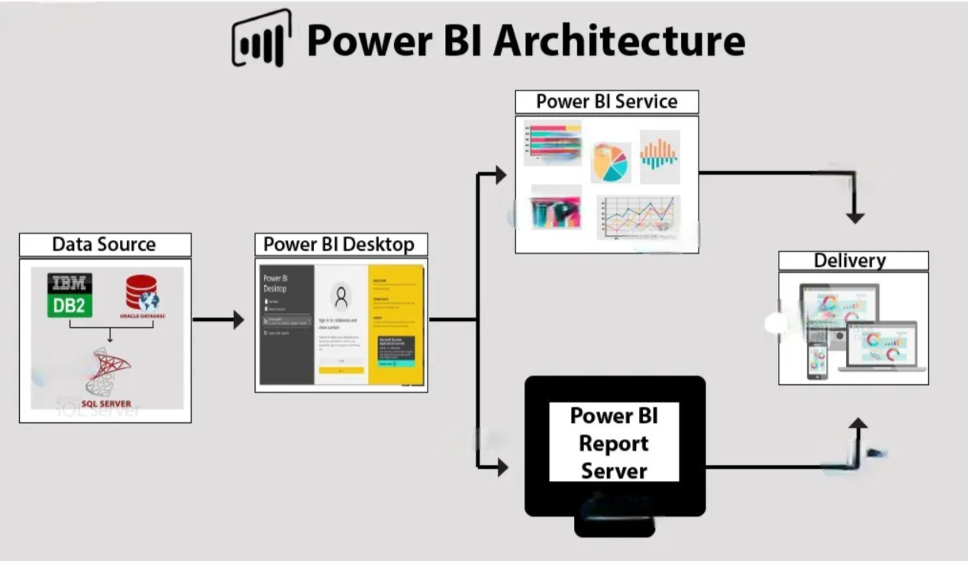
Figure 18 - Architecture work with visualization tools
Data Sources : An essential component of Power BI is its vast range of data sources. I can import data from files in your system, cloud-based online data sources or connect directly to live connections. If I import from data on-premise or online services, there is a limit of 1 GB. Some commonly used data sources in Power BI are: Excel, Text/CSV, XML, JSON, Oracle Database, IBM DB2 Database, MySQL Database, PostgreSQL Database, Sybase Database, Teradata Database, SAP HANA Database, SAP Business Warehouse server, Amazon Redshift, Impala, Google BigQuery (Beta), Azure SQL Database, Salesforce Reports, Google Analytics, Facebook, GitHub, and in case I will use data warehouse is my data sources where I connect to it for visualization.
Power BI Desktop: Power BI Desktop is a client-side tool known as a companion development and authoring tool. This desktop-based software is loaded with tools and functionalities to connect to data sources, transform data, model, and create reports. You can download and install Power BI Desktop in my system for free. Using Power BI Desktop features, one can do data cleansing, create business metrics and data models, define the relationship between data, define hierarchies, create visuals and publish reports.
Power BI Service: Power BI Service is a web-based platform where you can share reports made on Power BI Desktop, collaborate with other users, and create dashboards.

Monitoring, Packaging and Security
We have established a strict security system, effective monitoring, and flexible packaging process to ensure the "DONASO" project is robust, safe, and easy to manage. These measures not only enhance security but also improve system maintainability and scalability.

Data security
In the Security section, I have implemented a comprehensive security system to ensure the safety and integrity of the "DONASO" project. Security measures mainly include user management, permissions, and schema usage.
Specifically, I have implemented the user management process carefully. This includes creating and managing user accounts with access to the system. Each user is given a separate account and secure login information. I have established permission levels for each user based on their tasks and responsibilities in the project. This ensures that only authorized people can access and perform specific operations. To ensure effective data organization and arrangement, we used schema to define the structure of the database. This helps protect data from unauthorized access and also enhances data integrity.
Additional, I created a schema during the ETL (Extract, Transform, Load) process of the "DONASO" project is not only an important step to organize data but also a key measure in system security. One of the specific reasons I adopted this approach for my project is: data integrity and normalization, SQL injection attack prevention, access control.
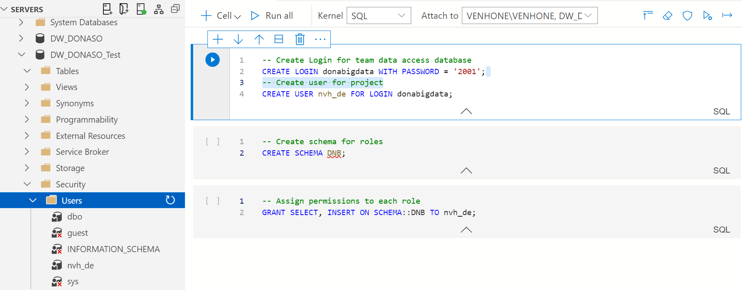
Figure 19 - Create and grant permissions to access users and databases
As we can see for the data warehouse there are only query and insert permissions, I have not given permission to delete or edit anything in the project's data warehouse.

Project monitoring and packaging
We have deployed Apache Airflow to perform monitoring and scheduling for project work. Airflow helps us automate data processing and it has been configured to optimize system performance. This includes scheduling concurrent tasks, monitoring system resources, and alerting when problems occur so they can be resolved promptly.
And finally to simplify and optimize the deployment process, we chose Docker as the packaging platform. Docker helps us package the application and all its dependencies into independent containers, making it easy to switch between development and production environments. I use Docker Compose to manage and deploy containers at the same time. This way, we ensure that every component of the project will function correctly and consistently. At the same time, automated build and deployment processes have been integrated to minimize errors and increase consistency.
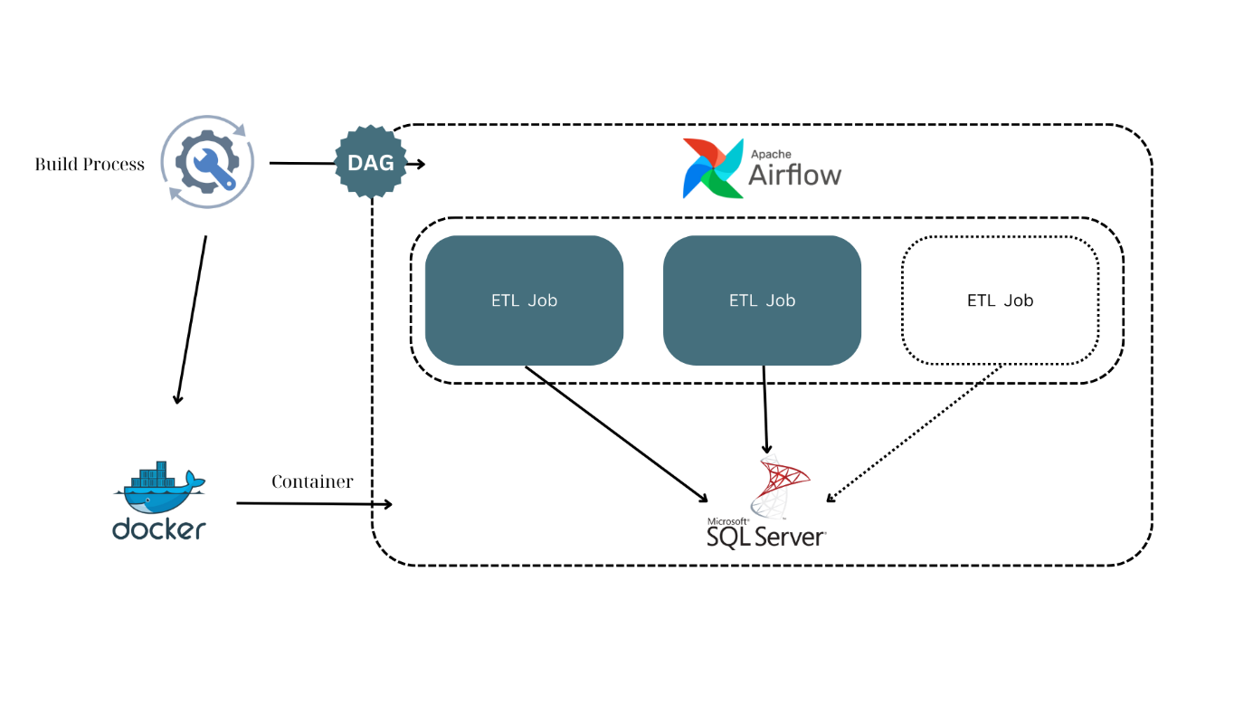
Figure 20 - Automated project scheduling, monitoring and packaging processes
As we can see Airflow can monitor the active jobs as well as will schedule the jobs to be executed according to the time we want the job to be executed, all of these jobs are monitored automatically so we get many benefits from this. And furthermore all of the above work we will package with Docker which can move these heterogeneous things onto any production or server environment.

CONSTRUCTION IMPLEMENTATION AND RESULTS

Environment and infrastructure settings

Install and configure data storage server
According to my current project, we basically need to build 3 database servers:
- The first is the datalake where my raw data will be stored. The data I will integrate from csv files, parquet or XML files or from other sources is dumped here, and in this data lake, the data is not yet standardized and cleaned (also known as raw data).
- Second, I need to install and configure a physical data warehouse that is necessary for me to actually deploy what I have designed. The data warehouse above. I use the SQL Server database management system as the location. Main storage for my data warehouse.
- Third, I have a data server where I will simulate data storage based on user usage behavior and waste classification management sent back to be saved by application developers. Here is one of the valuable data sources I use to extract into my big data system.
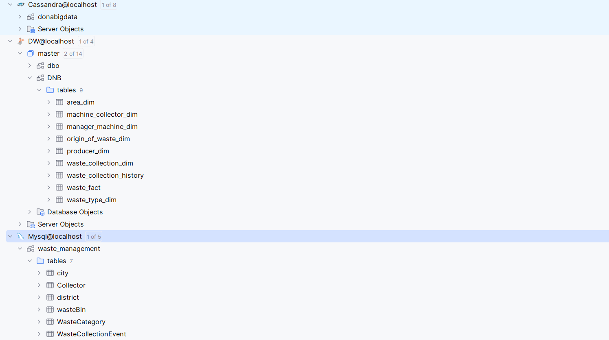
Figure 21 - Organize the initial server for the project

Install and configure Apache Spark
To install Apache Spark, we need to install the Java environment because Apache Spark is written in Scala, a language that runs on the Java virtual machine (JVM). Therefore, to run Apache Spark, we need to install Java on the server I am using to build the project because Spark uses JVM to execute the source code.
Then we need configuring environment variables in Windows adds the Spark and Hadoop locations to my system PATH. It allows you to run the Spark shell directly from a command prompt window.
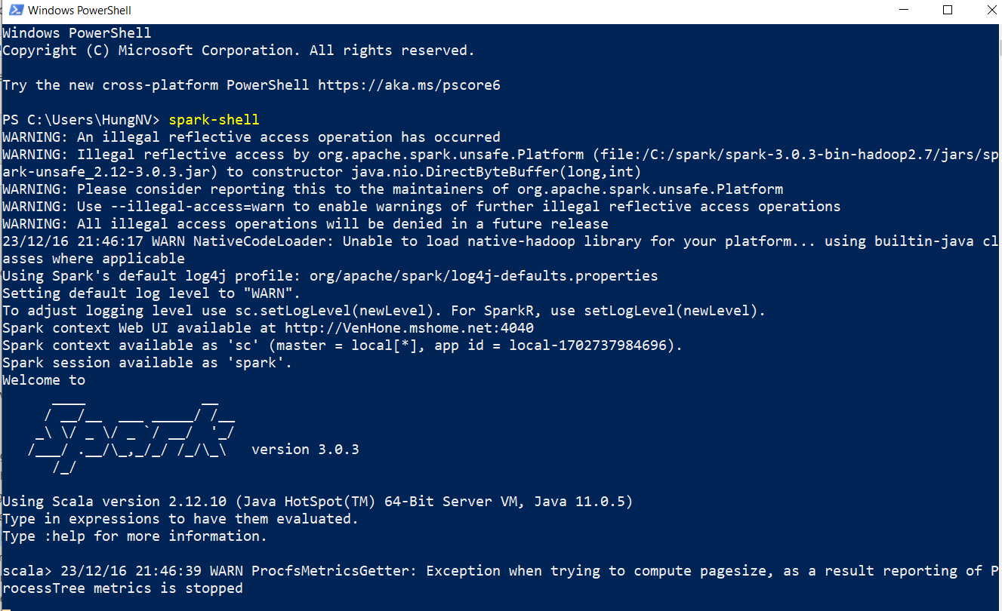
Figure 22 - Installed Apache Spark successfully

Configure connection to the operational database
My project is extracting data from an active database, one of the databases will be storing information from the 3T system, the data is stored in the MySQL database management system so To read data from it, we need to configure and set up access for it.
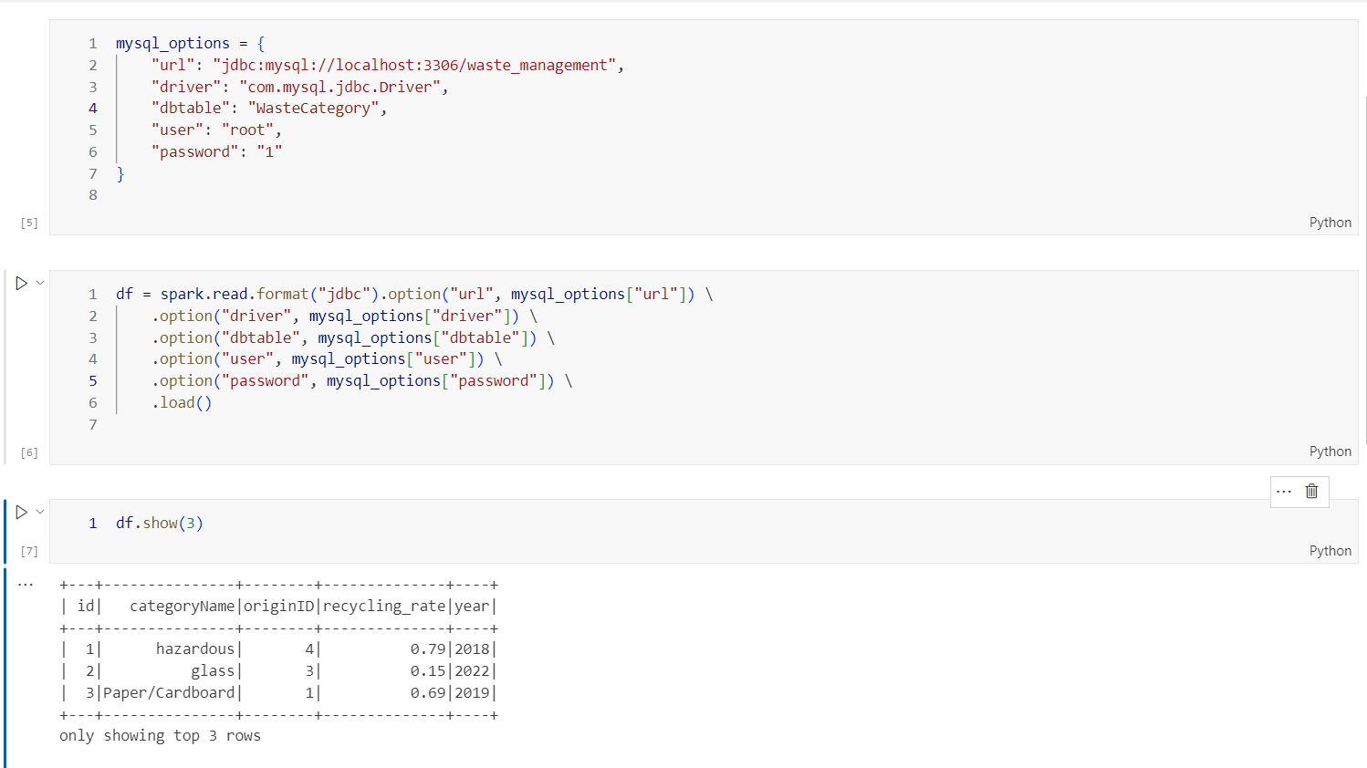
Figure 23 - Successful connection to the operational database

Configure connection to data warehouse
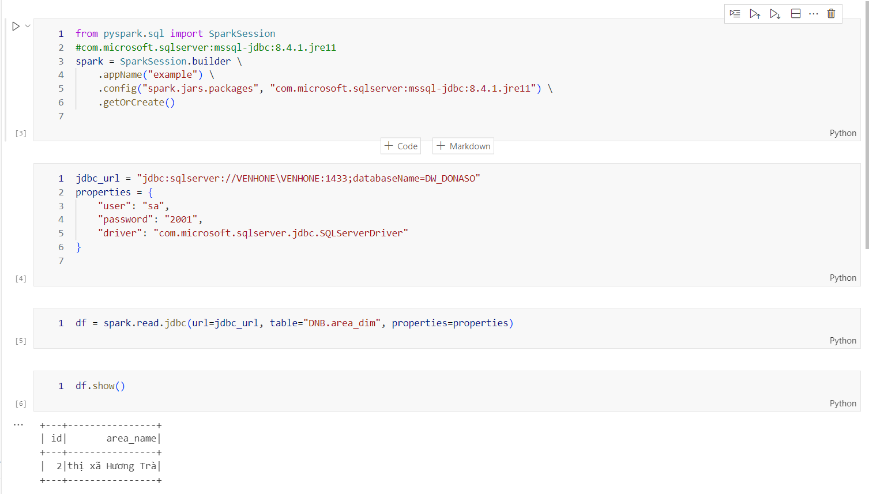
Figure 24 - Successful connection to the data warehouse

Configure connection to data lake
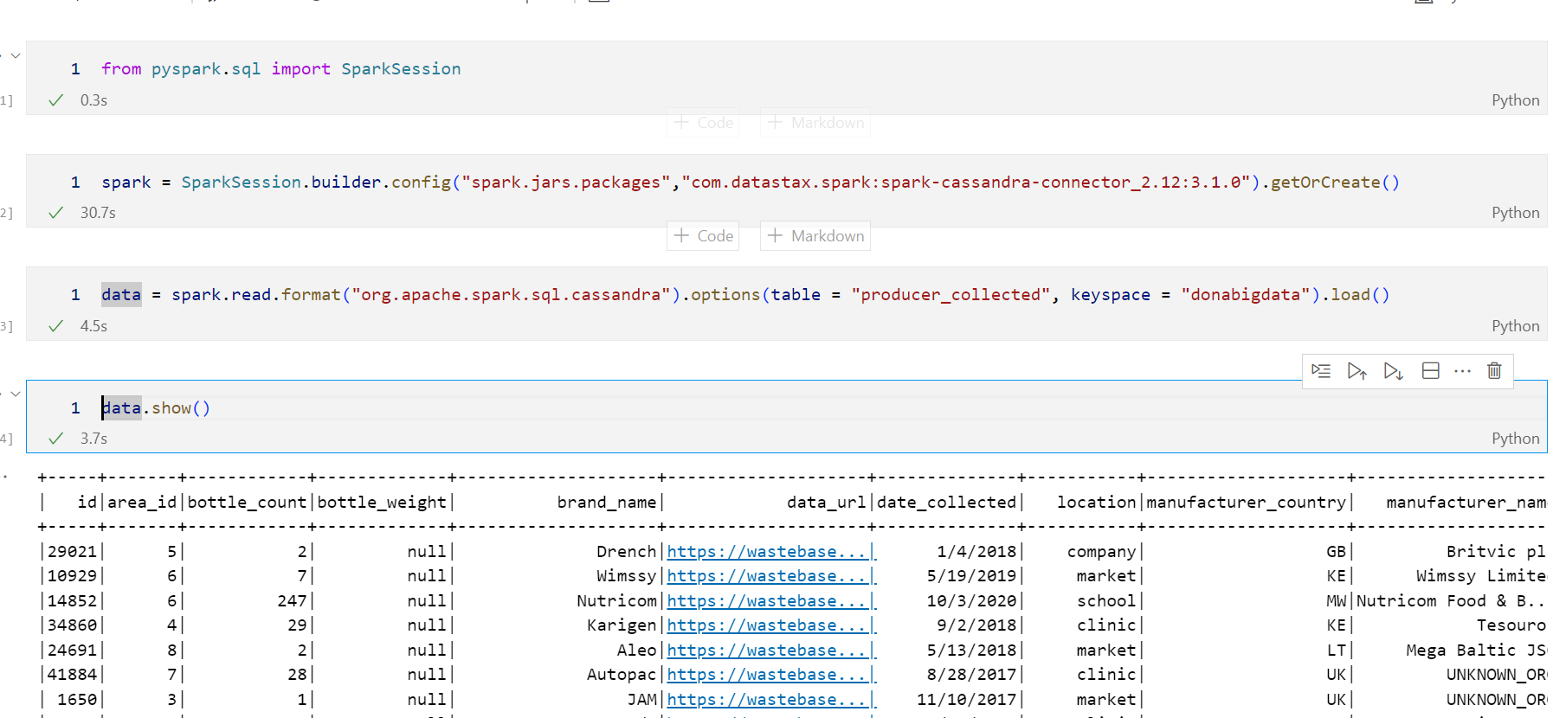
Figure 25 - Successful connection to the data lake

Data simulation process
As I said before, because the data I cannot have is direct and real, I have to fake the data, but my fake data must be based on the project's data structure, specifically we have a taxonamy file. about the garbage on which we can fake the data.
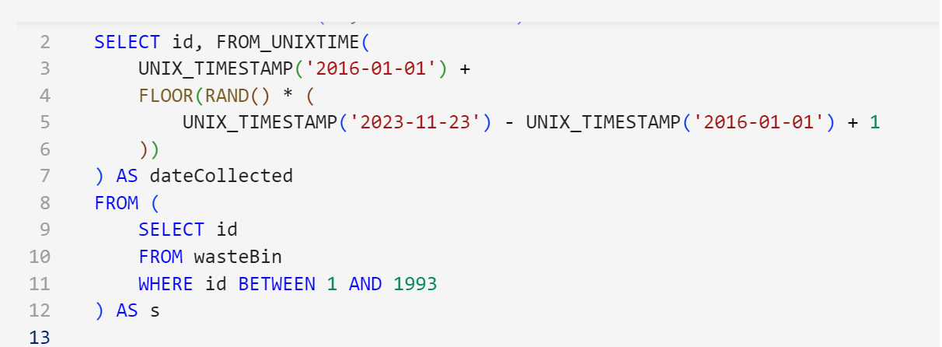
Figure 26 - Data time simulation code
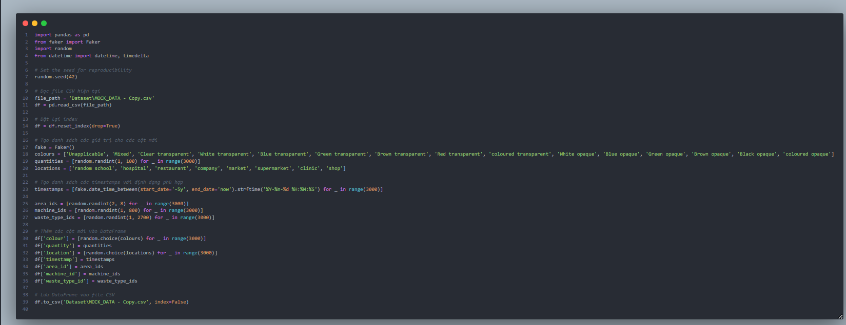
Figure 27 - Data fields simulation code
We will fake data on dates, locations, colors and other types of garbage, etc. As above, I have demonstrated how I fake data and that is one of the parts that I have done. fake data for this project.

Implement data warehouse at the physical level
Based on the conceptual and logical data warehouse I designed above, we can now deploy a physical data warehouse based on the object information tables that I also outlined above. And we will deploy this physical data warehouse using the SQL Server database management system.
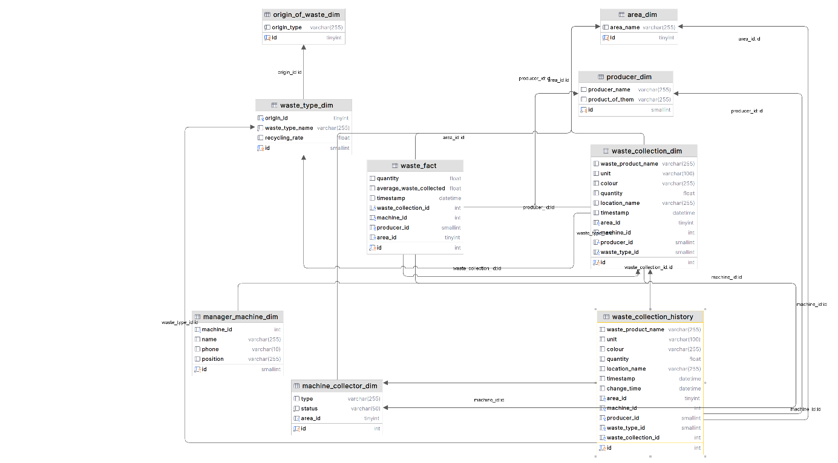
Figure 28 - Data warehouse at the physical level
When deploying a data warehouse at the physical level, I always pay attention to how to deploy data storage to improve data quality. Data quality should be a priority. Strong data governance practices ensure clean data and encourage adherence to rules and regulations and I should design for optimized query performance, pulling only relevant data, using efficient data structures, and tuning systems often.

Implement ETL Processing
Next, we proceed to implement the data ETL process as previously designed. From researching theoretical bases as well as applying technological techniques, we proceed to practice ETL steps on all dimension tables and fact tables of the data warehouse from the source to the destination in the best way. With data tables that have been cleaned from the source, we only need to select the columns to load the data into.
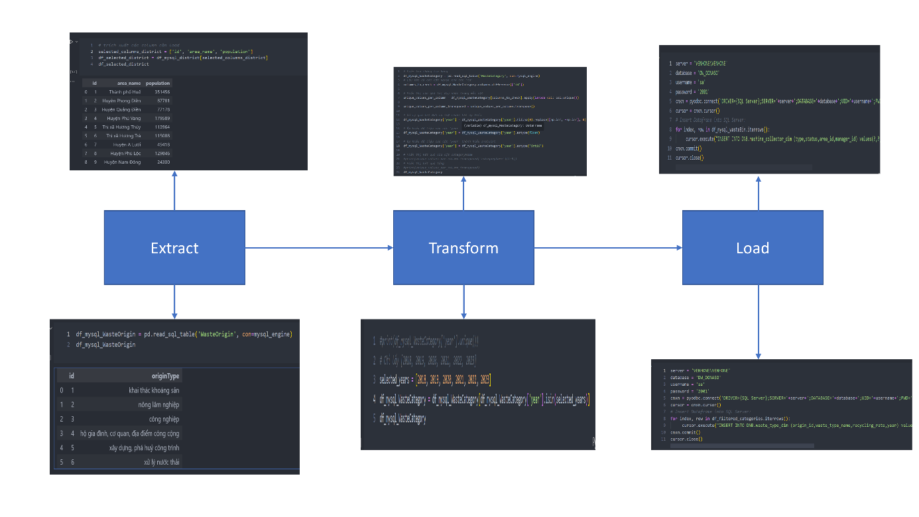
Figure 29 - Part of the data ETL process

Build data visualization reports
When building reports based on an existing data warehouse, I always follow certain principles, in which the principle of providing context according to business requirements is one of the important factors [9]. Data landscape helps users and waste managers interpret data accurately. To do this, I use labels, headings and annotations to clarify data points and trends. Furthermore, for waste data to lead users and waste managers to make data-driven decisions, we need to tell stories based on the data, which is done by arranging direct visualize into a logical order so that I, the presenter of the report, can tell a story based on the data. To do this effectively, we need to initially correctly identify the problem. What is the purpose of building these graphs, who are the listeners who are listening to us talk about waste data so that we can come up with the right graphs? As my project manager wants a. The chart shows the total amount of waste over the years (specifically, 5 years to compare the increase in waste, and the chart shows that for the districts of a city, ...).
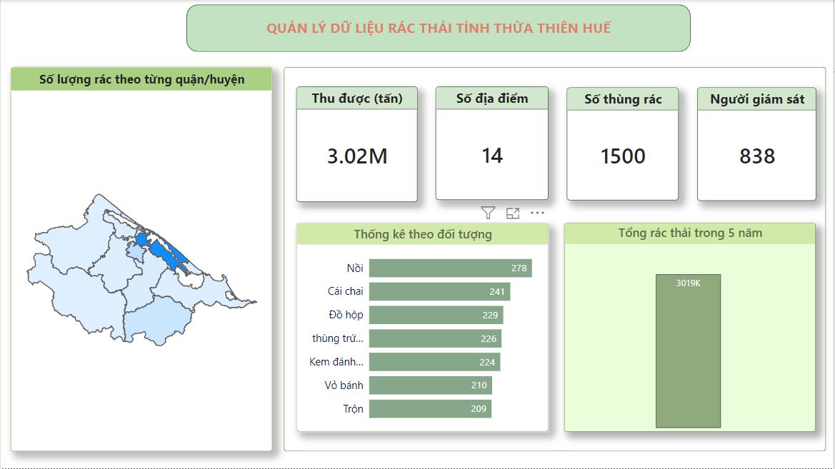
Figure 30 - Page dashboard overview
I have built a shape map of the city belonging to the project I worked on, I will give this shape map tooltip in and it will mean adding tooltips to maps in Power BI can enhance the interactivity and information display for users. Tooltips provide additional details or context when users hover over specific elements on a map.
Next we need a page to track detailed waste data, we can track waste according to popular locations, the total amount of waste released into the environment according to the manufacturer, we want know what the most commonly collected waste products are, what type of waste it is, and more we can monitor the waste collection process (monitor information of smart trash cans, who is monitoring that trash and the trash collection time), in addition we will have a chart to statistics on the amount of waste each year along with its rate, this helps us keep track be informed about waste (assess waste consumption and production, efficiency of recycling processes,...).
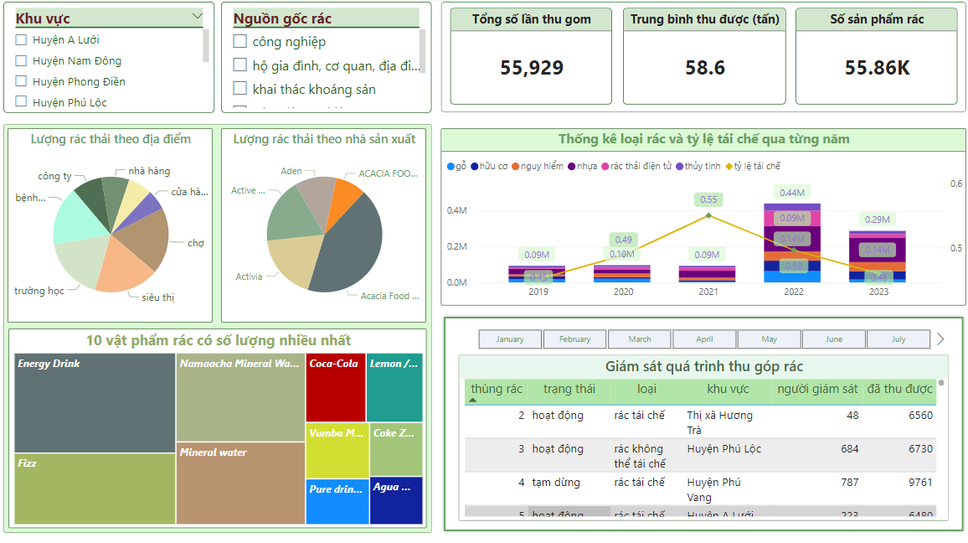
Figure 31 - Page waste track
In Power BI, filtering and interaction are crucial functionalities that enhance the effectiveness of data visualization and analysis, especially when dealing with waste management projects. Here are several reasons why filtering and interaction are necessary in Power BI for this projects: focus on relevant data, dynamic exploration, comparisons and trends,...
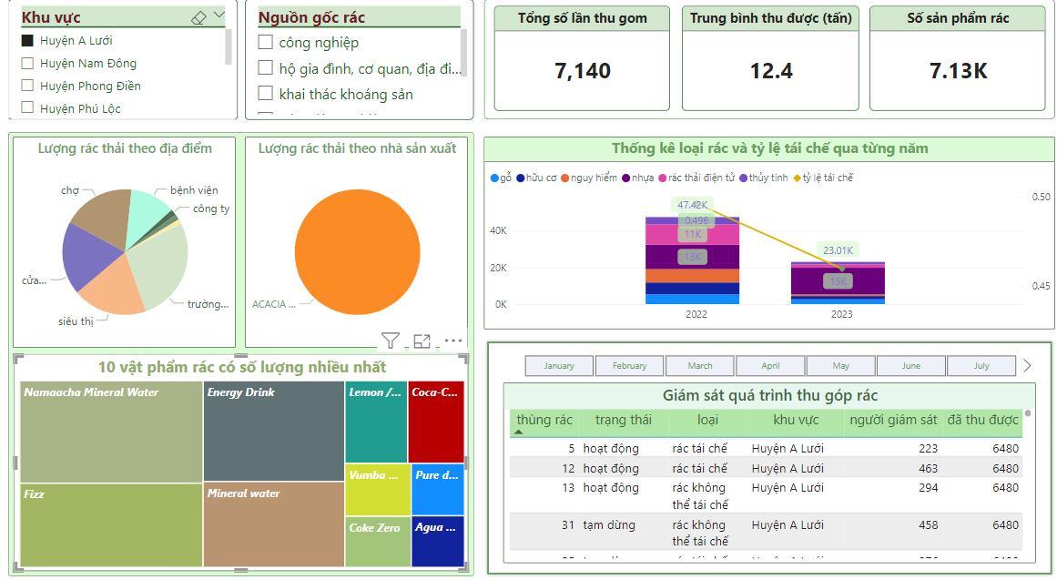
Figure 32 - Interaction with page waste track

Online report sharing process
To share my report to users and project members easily I used OHBI online platform. OHBI is a software service that helps people create and share Power BI reports without needing to own a Power BI account or download software to view PowerBI reports [10]. This is very good for those who no technology expertise.
OHBI will store the report in Microsoft Power BI Service according to the specified Workspace. OHBI is committed to information security according to their regulations and furthermore, the report creation/sharing functions on OHBI's premium workspace and user's workspace are free forever.
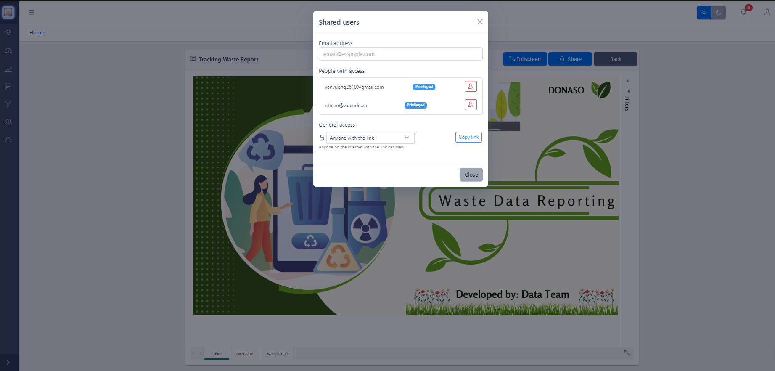
Figure 33 - Grant users permission to view reports
As we can see, when I share my powerBI report to accounts that have been granted permission to view the report, it will add the report and send the updated report to the system for the gmail that was added from me, I can disable any user's permission to view reports.
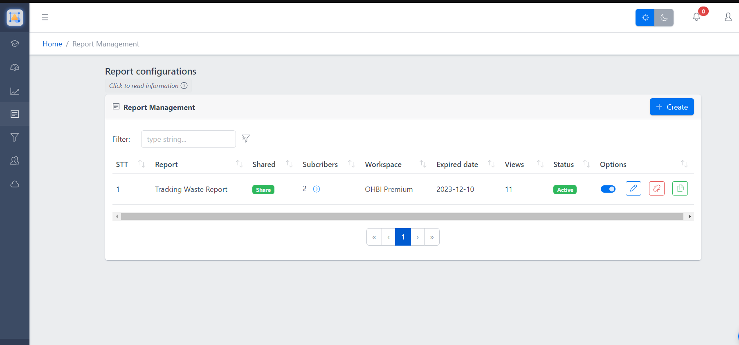
Figure 34 - Monitor and control shared reports
When a report is shared, I can manage each person's access to the report, including managing the number of accounts registered to view the report, the expiration date of this report for users, number of report views, functions such as turning off reports, editing, are very convenient for me in managing reports without spending a lot of time operating and designing a platform for managing and sharing reports

CONCLUSIONS AND SUGGESTIONS

Conclusions
Project effectiveness: The project has achieved great achievements by successfully building data pipelines and data warehouses from many different sources with many new data processing technologies, dashboards built with PowerBI are created with high visualization capabilities, providing a comprehensive overview information from data. At the same time, the project has brought many valuable experiences in working independently with many different technologies.
Although the project has achieved success, there are also challenges such as lack of real data to process, the process of creating fake data has many problems with the output target. Because time and knowledge are limited, exposure to working with new data processing technologies is difficult. Furthermore, resources and services to make projects are limited, so projects cannot be implemented completed in the best possible way. But with experience working in practice at businesses as well as taking advantage of my own self-study ability, I have been able to apply a number of methods to optimize and solve problems that businesses as well as myself have encountered., set, for this project, so I have partly resolved the challenges I encountered and always, make plans and proposals to develop the project better and always have a clear direction. For the project when deployed in the actual product environment.

Suggestions
System optimization: consider implementing performance improvement solutions such as caching, load balancing, distributed tasks and suggestions to ensure that the donabigdata system can scale flexibly to meet the needs of customers. There is a growing need to handle waste data.
Expanding processing capabilities: to improve data processing capabilities, I have proposed implementing cloud solutions to take advantage of flexibility and easy scalability. We will research cloud platforms popular today (AWS, Azure or Google cloud). This will include the process, schedule and associated costs. In the long run, this will ensure smooth integration between cloud data and data stored on-premises, but at the same time we always adhere to cloud-based data management to ensure Optimize storage costs for the project.
Data security and recovery: for good data security while working with data, I always recommend learning about how our data operates. When we understand the data lifecycle in the project, we can monitor, log and test automated access security (ready to use CI/CD for part of my data. This could save the ability to do tasks testing my manual data that my team), furthermore we will encrypt sensitive data this will include we will encrypt data fields that carry important project information to absolutely ensure unauthorized data access during our project implementation. To ensure data integrity, we always review and recommend data backup and restore, this will involves creating a copy of data to protect against data loss due to accidental deletion, hardware failure, or other types of disasters. The primary goal of backing up data is to ensure that it can be recovered quickly and easily in the event of a problem. Backups are typically performed on a regular basis (e.g. daily, weekly, or monthly) and are often stored in a different location than the primary data to protect against site-level disasters.
Combining smart technology like IOT to collect real-time data from smart devices during waste processing along with integrating artificial intelligence into the system to take full advantage of warehouse data benefit to improve waste data analysis and prediction.

REFERENCES

[1] | DNIIT, "Pitch Deck Donaso," DNIIT, Danang, 2023.
[2] | Tommy, "magestore," 18 April 2020. [Online]. Available: https://insights.magestore.com/posts/kien-truc-du-lieu-lon. [Accessed 12 2023].
[3] | T. Cleo, "cleo," [Online]. Available: https://www.cleo.com/blog/knowledge-base-on-premise-vs-cloud. [Accessed 2023].
[4] | SQream, "panoply," 2022. [Online]. Available: https://panoply.io/data-warehouse-guide/. [Accessed 2023].
[5] | CRET.HUE, "BAO CAO TOM TAT DANH GIA KY THUAT VE HE THONG QUAN LY CHAT THAI HUE," Hue, 2021.
[6] | V. Pham, "bizflycloud," 31 07 2020. [Online]. Available: https://bizflycloud.vn/tin-tuc/etl-la-gi-cach-thuc-hoat-dong-cua-etl-va-tai-sao-can-su-dung-elt-20200731175234501.htm. [Accessed 2023].
[7] | "javapoint," [Online]. Available: https://www.javatpoint.com/etl-process-in-data-warehouse. [Accessed 2023].
[8] | susheelaakulu, "medium," [Online]. Available: https://susheelaakulu.medium.com/power-bi-architecture-7-components-explained-with-working-4d12cd266da5. [Accessed 2023].
[9] | "mastering-da," [Online]. Available: https://mastering-da.com/4-meo-thiet-ke-hay-cho-power-bi/. [Accessed 2023].
[10] | T. Phong, "onhandbi," [Online]. Available: https://onhandbi.com/. [Accessed 2023].
[11] | D. startup, "GIAI PHAP CONG NGHE THONG MINH CHO VAN DE RAC THAI," DNIIT, Danang, 2023.

